John Sanford Shepherd
October 17, 1847 – September 2, 1911

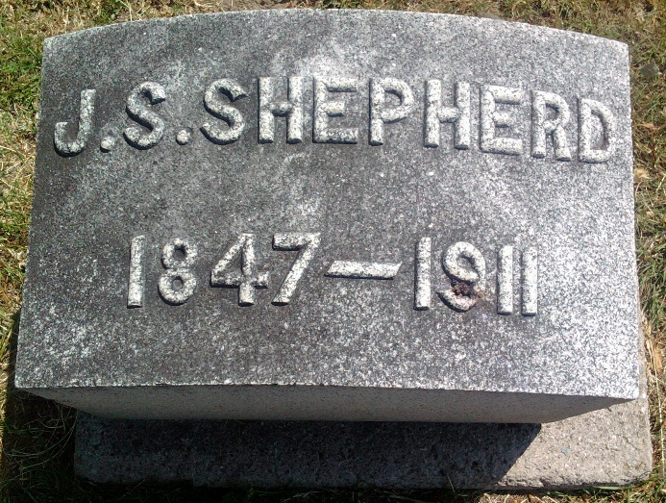
Photo by Thomas Liby

F. J. Shepherd and wife, two sons, Mrs. Enna Shepherd, Mr. and Mrs. Amos Stiner attended the funeral of John Sanford Shepherd Tuesday.

Berne Witness, Adams County, Indiana
Friday, Sept. 8, 1911
**

Indiana, U.S., Death Certificates, 1899-2017
Name John Sanford Shepherd
Gender Male
Race White
Marital Status Married
Age 63y 10m 16d
Birth Date 17 Oct 1847
Birth Place Ohio
Death Date 2 Sep 1911
Death Place Bluffton, Wells, Indiana, USA
Father John Steven Shepherd
Mother Susan Ray Hartpence
Spouse Mary Jane Wiest Shepherd, informant
Burial Fairview Cem 9/5/1911
**

JOHN S. SHEPHERD

This public-spirited and highly respected resident of Nottingham township, Wells county, Indiana, was born in Darke county, Ohio, October 15, 1847, a son of john S. & Susan (Hartpence) Shepherd. John E., a native of Pennsylvania, was a son of Dennis and Esther Shepherd, also of the keystone state. He was taken to Butler county, Ohio, when a small boy, and subsequently to Darke county, in the same state, and in these two counties he reached manhood’s years. In the latter county John S. Married Miss Harpence, a native of New jersey, the ceremony taking place at Ithaca, where he at once engaged in the mercantile business and followed it until 1847, when he was elected county recorder and removed to Greenville. He was re-elected to succeed himself, and remained in the city until the spring of 1870, when he went to Adams county, Indiana, and settled on the farm now occupied by his youngest son, F. J.
John S. Shepherd had traded a half lot in Ithaca for one hundred and sixty acres of land in Adams County, but before removing thither purchased an additional tract of one hundred and eighty acres, making a total of three hundred and forty, nearly all of which was under a good state of cultivation prior to his death, which occurred at the home of his son, John S., July 18, 1893. His wife, Susan, had preceded him to the grave, dying November 19, 1882, leaving him nine children, viz: W. H.; W. W., deceased; Thomas M., who died in the army; Sarah E., who is married to Charles W. Hartsell; John S., the subject proper of this sketch; Andrew, who died in childhood; F. J.; Mary M., wife of Joseph French, and Ann S.
John S. Shepherd attended the public schools of Greenville, Ohio, until twenty-one years of age, when he rented his father’s farm, in 1870. April 16, 1871, he married Miss Mary J. Weist, who was born in Pickaway county, Ohio, October 17, 1849, a daughter of Joseiah and Catherine (Rose) Weist. Josiah Weist was born in Pennsylvania, but located in Pickaway county, Ohio, in 1850, whence he came to Indiana and settled on land which had been entered by his father, Peter Weist, who had preceded him. Catherine died on their homestead, and Josiah then went to live with his youngest child, who is also named Josiah and who resided in Vera Cruz, Indiana.
Josiah and Catherine (Rose) Weist had a family of nine children, who were named, in order of their birth, as follows: Mary, now Mrs. J. S. Shepherd; Sarah A.; John W., deceased ; Lewis A., deceased; Sylvester M., deceased; Alice L., married to J. D. Kreps; George; Emma and Josiah.
John S. Shepherd, for three years after marriage, continued to live on his father’s farm, and then came to Nottingham township, Wells county, Indiana, and located on the Amos Warren farm, where he lived for about two years. In the spring of 1877 he took charge of the poor or county farm, held the position for two years, then moved to Bluffton and conducted a photograph gallery for two years. In 1884, Mr. Shepherd settled on the farm he at present occupies, and which comprises ninety-four acres, which he had purchased in 1879, having, with the laudable aid of his wife, earned sufficient money to pay for the place. When Mr. and Mrs. Shepherd began housekeeping that had a cooking stove; the converted a store box into a cupboard, and the father of Mrs. Shepherd presented the young couple with four chairs and a table. Mrs. Shepherd had worked out to earn the means with which to buy a bed and some dishes, and Mr. Shepherd’s mother gave them sixteen chickens. They also had a cow, and with the eggs and milk which they sold, and what they consumed themselves, they managed to get along the first year without any great hardship, and at the close of the year had raised eighty chickens. The second year the eggs laid by the hens were disposed of for sixty-seven dollars and ten cents, Mrs. Shepherd also selling turkeys that netted her sixty-five dollars. When Mr. Shepherd settled upon his farm there were about thirty-five acres cleared, but now he has eighty acres from which the surpfluous timber had been removed; he has also thoroughly ditched the place and has made all the improvements, which are fully up-to-date. The farm now comprises one hundred and seventy-four acres, eighty of which are in Adams county. Mr. Shepherd is also the owner of eight producing oil wells, from which he has derived about one thousand dollars from the lessees as his half interest, while V. L. Reed, of Mount Zion, owns the other half. Recently, Mr. Shepherd has converted his place into a pasture farm, on which he breeds Red Polled cattle and Shropshire and Oxford Down sheep. He also owns the old home farm in Greenville, Ohio.
Mrs. and Mrs. Shepherd are members of the Baptist church, and in politics Mr. Shepherd is a Democrat, and under the auspices of his party has served for two years as treasurer of Bluffton, and has twice made the race for the office of county treasurer.

