Mary J. (Weist) Shepherd
October 17, 1849 – June 16, 1929

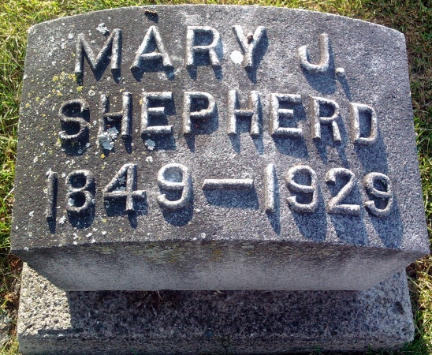
Photo by Thomas Liby
Indiana, U.S., Marriages, 1810-2001
Name Mary Jane Wist
Gender Female
Event Type Marriage Registration (Marriage)
Marriage Date 3 Apr 1871
Marriage Place Indiana, United States
Spouse John S Shepherd
Officiator Jas R McCleery
Page 146
FHL Film Number 002318462
**
April 16, 1871, he [John Sanford Shepherd] married Miss Mary J. Weist, who was born in Pickaway county, Ohio, October 17, 1849, a daughter of Joseiah and Catherine (Rose) Weist. Josiah Weist was born in Pennsylvania, but located in Pickaway county, Ohio, in 1850, whence he came to Indiana and settled on land which had been entered by his father, Peter Weist, who had preceded him.
Biographical Memoirs of Wells County, Indiana; Hugh Dougherty, et al; B. F. Bowen, publisher, Logansport, Ind., 1903, p. 271

