Michael K. Sheets
February 23, 1929 – January 12, 1998

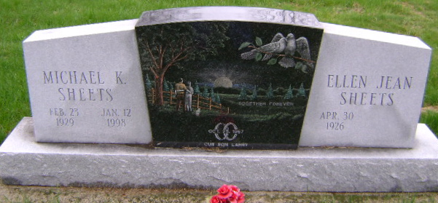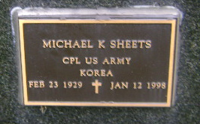
Photos by Bruce Sonner

Michael K. Sheets, 68, of Bluffton died Monday at Caylor-Nickel
Medical Center. The Bluffton native was employed at Tokheim Co. for 21 years. He was also employed at Franklin Electric Co. He was a Korean War veteran.
Surviving are his wife, Jean; a son, Larry K. of Park Forest, Ill.; a
brother, Jerry of Bluffton; sisters, Karen Dubach of Linn Grove and Anita Hoye of Callisbelle, Mont.; and one granddaughter.
Services are 10:30 a.m. Thursday at First Church of the Nazarene, with calling one hour before services. Calling is also from 1 to 9 p.m.
Wednesday at Goodwin Memorial Chapel. Military graveside services will be in Fairview Cemetery.
Memorials are to American Heart Association or Lydia Murray Fund.

News-Sentinel, Allen County, Indiana
January 13, 1998
**

Michael K. Sheets, 68, Bluffton, died Monday in Caylor-Nickel Medical Center, Bluffton. Among survivors are his wife, Jean; a son; a brother; and two sisters, including Karen Dubach, Linn Grove.
Funeral services will be held at 10:30 a.m. Thursday in First Church of the Nazarene, Bluffton, with burial in Fairview Cemetery, Bluffton.
Visiting hours are until 9 p.m. today in Goodwin Memorial Chapel, Bluffton.

Decatur Democrat, Adams County, Indiana
January 14, 1998

