Ellen Jean (Kleinknight) Sheets
April 30, 1926 – December 31, 2019

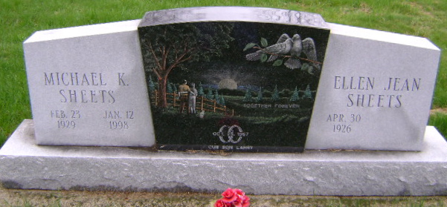
Photo by Bruce Sonner

Ellen Jean Sheets, 93, passed away Tuesday, December 31, 2019 at River Terrace Estates in Bluffton. Jean was born in Wells County, IN on April 30, 1926 to Chalmer and Georgia Glenetth (Elzey) Kleinknight, both parents preceded her in death. She married Michael K. Sheets in Angola, IN on October 25, 1957, he preceded her in death on January 12, 1998.
She was a lifelong member of the Bluffton Church of The Nazarene in Bluffton. Jean retired from Franklin Electric in Bluffton after 34 years of service. She enjoyed working puzzles, reading scripture and traveling. Jean was a wonderful caregiver to her husband for many years.
Jean is survived by her son; Larry K. (Susan) Sheets of Bourbonnias, IL., a granddaughter; Katie Sheets of Downers Grove, IL.; a brother; James Kleinknight of Bluffton, several nieces and nephews. Aside from her parents and husband, she was preceded in death by her sister; Martha Carnall.
Visitation will be held on Monday, January 6, 2020 from 4:00 to 7:00 PM at Goodwin – Cale & Harnish Memorial Chapel in Bluffton. Graveside services will be held at 10:30 AM on Tuesday, January 7, 2020 at Fairview Cemetery in Bluffton, Rev. Tim Miller will officiate services.
Memorials may be made to Family LifeCare of Berne, IN

Goodwin – Cale & Harnish Memorial Chapel, Wells County, Indiana

