Charles Hillard Shadle
June 13, 1949 – March 8, 1992

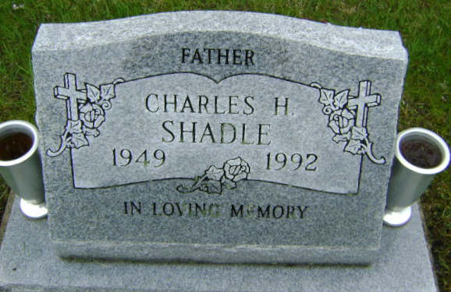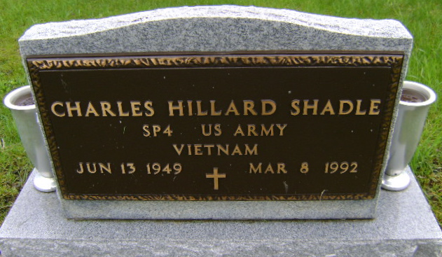
Photos by Bruce Sonner

CHARLES H. SHADLE, 42, of Roanoke died yesterday in Lutheran Hospital. The Bluffton native was a 20-year employee of Bunsold Trucking Co. and veteran of the Vietnam War.
Surviving are a daughter, Lisa M. Shadle of Roanoke; a son, Brent A. of Roanoke; a sister, Nancy Kelley of Markle; and brothers, Jim L. of Fort Wayne and Steven D. of Fallbrook, Calif.
Services are 11 a.m. Wednesday in Elzey & Haggard Home for Funerals, 6810 Old Trail Road, where calling is 2 to 5 and 7 to 9 p.m. tomorrow. Burial will be in Fairview Cemetery, Bluffton. Preferred memorials are gifts to charity.
News-Sentinel, The (Allen County, Indiana)
Monday, March 9, 1992
**

Indiana, U.S., Death Certificates, 1899-2017
Name Charles H Shadle
Gender Male
Race White
Marital Status Divorced
Age 42
Birth Date 13 Jun 1949
Birth Place Bluffton, Indiana
Death Date 8 Mar 1992
Death Place Fort Wayne, Allen, Indiana, USA
Death Registration Date 1992
Father Hillard A Shadle
Mother Leah M Bickel
Informant Jim L. Shadle, brother
Burial 3/11/1992 Fairview Cemetery

