Dora Celestia (Pease) Seabold
June 16, 1872 – March 14, 1941

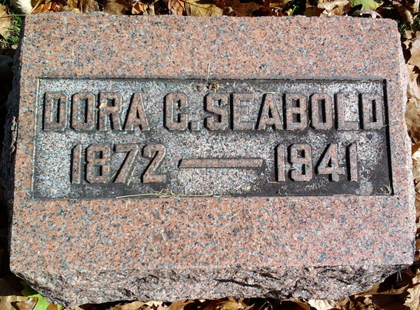
Photo by Thomas Liby

MOTHER OF JOSEPH SEABOLD EXPIRES

Bluffton, March 17 - Mrs. Dora Seabold, 68, widow of Christian P. Seabold, died Friday afternoon at her home here, after a long illness. Surviving are a son, Joseph, and a daughter, Mrs. Virginia Costello, both of this city, and a brother, Joseph Pease, east of Bluffton.
Mrs. Seabold was a member of the First Evangelical and Reformed church of this city. Services were held at the church at 2 p.m. Sunday. Mr. and Mrs. L. L. Yager attended the funeral of Mrs. Dora Seabold at the Reformed Church at Bluffton, Sunday afternoon. Mrs. Seabold was a relative of Mr. Yager.

Adams County Historical Museum
1940-1941a Scrapbook, image 39
Handwritten date: Monday, 1941
**

Indiana, U.S., Death Certificates, 1899-2017
Name Dara C Seabold [Dora C Seabold]
Gender Female; Race White
Marital Status Widowed
Age 68y 8m 28d
Birth Date 16 Jun 1872
Birth Place Adams County, Indiana
Death Date 14 Mar 1941
Death Place Bluffton, Wells, Indiana, USA
Father Elizah Pease
Mother Verginia Walters
Spouse C R G Seabold
Informant Joe Seabold
Burial Fairview 3/16/1941

