Christopher Philip G. Seabold
November 6, 1866 – September 18, 1923

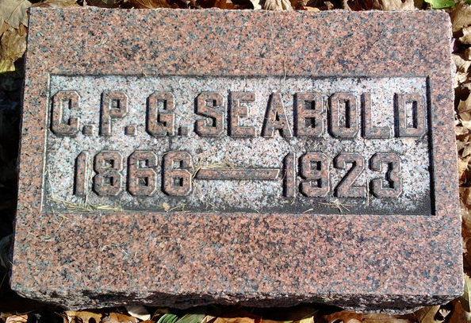
Photo by Thomas Liby

Seabold Funeral Friday Morning At Bluffton
Funeral services for Chris Seabold, prominent Bluffton resident who died in the Wells County Hospital late Tuesday night, will be held at 10:30 o'clock Friday morning from the First Reformed Church in Bluffton. Burial will be made in the Fairview Cemetery. Mr. Seabold was well known by many Decatur and Adams County people.
Decatur Daily Democrat, Adams County, Indiana
Thursday, September 20, 1923
**

Indiana, U.S., Death Certificates, 1899-2017
Name C. P. H. Seabold
[C. P. G. Seabold]
Gender Male
Race White
Marital Status Married
Age 56y 10m 12d
Birth Date 6 Nov 1866
Birth Place Fort Wayne, Indiana
Death Date 18 Sep 1923
Death Place Bluffton, Wells, Indiana, USA
Death Registration Date 1923
Father George Seabold
Mother Melena Yager
Spouse Dora Pease Seabold, informant
Burial Fairview 9/21/1923

