Betty Alice (Coffield) Sawyer
November 26, 1928 – July 1, 1992

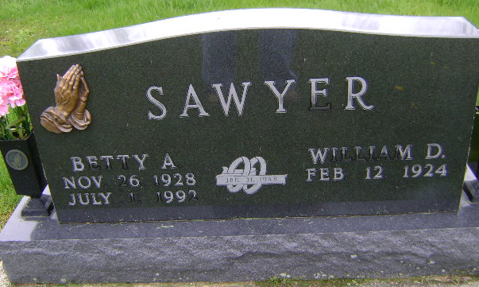
Photo by Bruce Sonner

MRS. WILLIAM (BETTY) SAWYER, 63, DIES; SERVICES FRIDAY

Mrs. Betty Alice Sawyer, 63, wife of William Sawyer, 700 West Spring St., died at 6:40 a.m. today at Cayle Nickel Hospital. Death was attributed to cancer and followed an illness of five years.
Mrs. Sawyer was employed in the accounting department of Franklin Electric Co. She was a member of the Wesleyan Church and a past president of the American Legion Auxiliary.
A native of Wells County, Mrs. Sawyer was born Nov. 26, 1928, a daughter of Clyde and Emma Fryback Coffield. Her married to William D. Sawyer took place Jan. 31, 1948 at Bluffton.
Mrs. Sawyer was a 1946 graduate of Bluffton High School.
Surviving, in addition to the husband, are two sons, Steve Sawyer and Doug Sawyer, both of Bluffton; two brothers, Rex Coffield and Ronald Coffield, both of Bluffton; and five grandchildren.
Services will be at 2 p.m. Friday at Goodwin Memorial Chapel, where calling will begin at 1 p.m. Thursday. Rev. Ralph Westafer and Rev. Garry Beecher will officiate at rites and burial will be in Fairview Cemetery.
Preferred are memorials to the Wells County Cancer Society.

News Banner, Wells County, Indiana
July 1, 1992

