Larry “Soc” Rush
September 12, 1940 – May 5, 2010

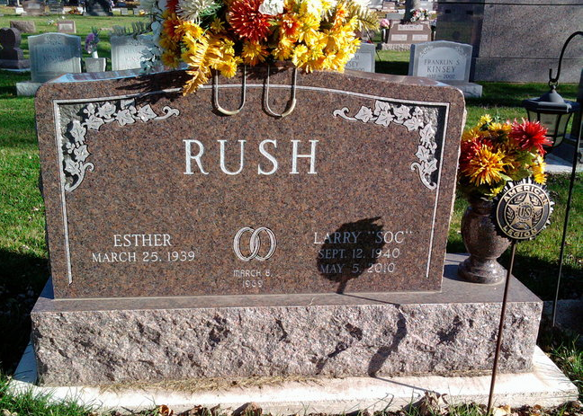
Photo by Thomas Liby

Larry "Soc" Rush, 69, of Chandler, Ariz. and formerly of Bluffton, died Wednesday, May 5, 2010, at Banner Desert Medical Center in Mesa, Ariz., due to complications from a recent illness. Larry was born in Bluffton on Sept. 12, 1940 to Owen and Katherine Rush. He married Esther (Kneuss) Rush on March 8, 1969; she survives.
Larry was a graduate of Bluffton High School and served his country honorably with the United States Army. Larry retired from the Bluffton Post Office in 1995 after 30 years of government service as a letter carrier. After retiring Larry and his wife Esther moved to Chandler, Ariz. While in Arizona, Larry worked as a security officer at Harrah's Ak-Chin Casino.
Larry was a member of Post #111 of the Bluffton American Legion. He loved spending time with his family and friends, bowling and golfing. Those who knew him will remember his dedication, sense of humor and loving heart.
Surviving relatives include one daughter Cindy (Rush) Michaels of Chandler, Ariz.; one son Mike Rush of Albion; five grandchildren, Abby (Rush) Liebing of Fort Wayne, Jeff and Mitch Rush of Albion, and Brad and Austin Michaels of Chandler, Ariz.; and one great-grandchild, AvaLynn Liebing.
Larry was preceded in death by his parents, two brothers, Joe and Norm, and his sister Bonnie.
A graveside service will be held at 11 a.m. Saturday, August 7, 2010 at Fairview Cemetery in Bluffton. A reception will follow at the American Legion Post # 111 of Bluffton.

Thoma/Rich, Chaney & Lemler Funeral Home, Wells County, Indiana

