William C. “Charlie” Rudd
June 9, 1943 – September 7, 2016

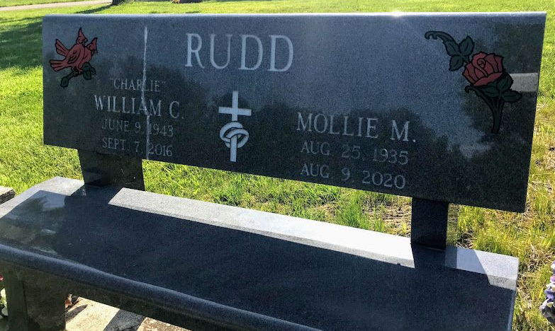
Photo by SMMR

William C. “Charlie” Rudd Sr., 73, of Bluffton, passed away at 9:17 PM on Wednesday September 7, 2016 at Lutheran Hospital in Fort Wayne. Charlie was born on June 9, 1943 in Winimac, Indiana to the late James Marshall and Rosetta (Stewart) Rudd. Charlie married Mollie M. Rudd who survives in Bluffton. Charlie had worked at Sterling Casting in Bluffton for several years and also had a scrap hauling business. Charlie and Mollie attended the Church of God. Charlie was a founder and manager of the Church of God food bank.
Charlie is survived by his Children William C. (Sandy) Rudd Jr. of Paintsville, KY, Milinda Sue (Ronnie) Cross of Granville, OH, Marsha Ann (Frank) James of Bluffton, Connie Rose Rudd of Las Vegas, NV, Irene (Kenneth) Blankenship of Gary, Carolyn (Don) Rowe of Catlettsburg, KY, Edgar Raymond (Lori) Angel of Columbia City, Ethel Angel-Kruger of Ashland, KY, Randy Angel of Bluffton, Jack Morlan of Craigville, Gladys Susie (Billie) Coffield of Liberty Center, 24 Grandchildren, 40 Great Grandchildren, Siblings, Roberta (Don) Keller of English Lake, Barbara Jo (Rudd) Cornelius of Plymouth, Garry Lee Rudd of Fort Wayne, Alford Rudd of North Judson. Charlie was preceded in death by his parents and a son Ricky Troy Angel.
A visitation will be held at the Thoma/Rich, Lemler Funeral Home 308 W. Washington St. Bluffton on Saturday September 10, 2016 from 1:00 to 4:00 PM. A funeral service will be held at the Funeral Home following the visitation at 4:00PM with Pastor John Roe officiating. Memorials may be made in Charlie’s memory to the Church of God Food Bank.

Thoma/Rich, Lemler Funeral Home, Wells County, Indiana
September 9, 2016

