Mollie Marie (Puckett) Rudd
August 25, 1935 – August 9, 2020

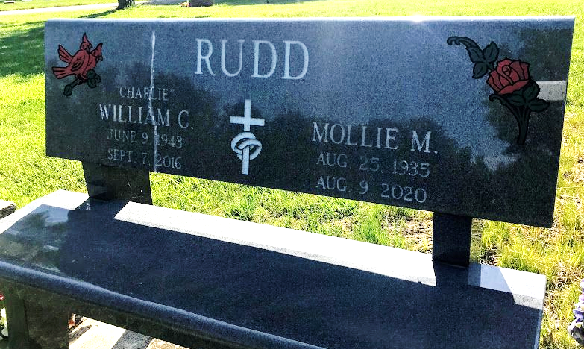
Photo by SMMR

Mollie M. Rudd, 84 of Bluffton, peacefully passed away on Sunday morning, August 9, 2020, at her residence. She was born on August 25, 1935 in Salyersville, Kentucky to Ervin & Ethel Mae (Rowe) Puckett.
Mollie worked for some time as a nurse aide in the therapy department of Knox Hospital. She was a longtime caregiver for others.
Mollie and William C. “Charlie” Rudd, Sr. were married in Catlettsburg, Kentucky and he preceded her in death on September 7, 2016. Mollie attended the Church of God and was active in the Bluffton Church of God’s food bank.
Mollie is survived by her children; Irene (Kenneth) Blankenship of Gary, Carolyn Sue (Don) Rowe of Catlettsburg, KY, Edgar Raymond (Lori) Angel of Merryville, Ethel Marie Angel of Ashland, KY, Randy Angel of Bluffton, Jack (Desire' Green) Morlan of Craigville, Gladys Susie (Billie) Coffield of Tocsin, Connie Rose Rudd of Las Vegas, NV., William C. Rudd, Jr. of Paintsville, KY, Milinda Sue (Ronnie) Cross of Fort Wayne, Marsha Ann (Frank) James of Bluffton, 25 grandchildren, 40 great grandchildren, 5 great-great-grandchildren, and brothers; Luther (Lisa) Mercer of Kenton, Ohio and George Puckett of Ohio.
Mollie is preceded in death by her parents, husband Charlie, a son Ricky Troy Angel and siblings; Ronnie Mercer, Lonnie Mercer, Troy Mercer, Ollie Puckett, Mary Bailey, Mae Pole, Pearlie Foreman and Brenda Hollers.
Visitation will be held at the Thoma/Rich, Lemler Funeral Home on Wednesday from 12 Noon to 3 P.M. A funeral service will be held at the Funeral Home following the visitation at 3 P.M. with Pastor John Roe officiating. Burial will follow at Fairview Cemetery in Bluffton. Memorials may be made in Mollies’ memory to the Visiting Nurse of Fort Wayne.
The family would like to thank Visiting Nurse, HomeCourt Home Care and Aging and In-Home Services for their special care they showed to Mollie.
The safety of the family and all visitors is our utmost priority. For everyone’s safety, we ask that you practice social distancing. Masks are required for visitation and for Mollie’s service at the funeral home. We appreciate your cooperation and patience.

Thoma/Rich, Lemler Funeral Home, Wells County, Indiana

