Eva Edna (Martz) Rotharmel
January 1865 – December 28, 1906

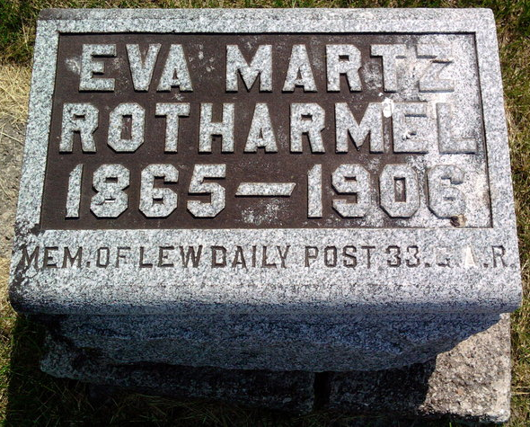
Photo by Thomas Liby
Indiana Deaths, 1882-1920
Name: Eva Edna Rotharmel
Date: 28 Dec 1906; Location: Bluffton
Age: 41 yr; Gender: Female; Race: White
Source Location: County Health Office, Bluffton
Source Notes: The source of this record is the book H-17 on page 37 within the series produced by the Indiana Works Progress Administration.
**
Indiana Marriage Collection, 1800-1941
Name: Eva E. Martz
Spouse Name: Albert Rotharmel
Marriage Date: 30 Nov 1887; Marriage County: Wells
Source: Wells County, Indiana Index to Marriage Record 1837 - 1920 Inclusive Vol; W. P. A. Original Record Located: County Clerks Of; Book: C- 7, OS Page: 100

