Albert Z. Rotharmel
April 1, 1862 – May 8, 1940

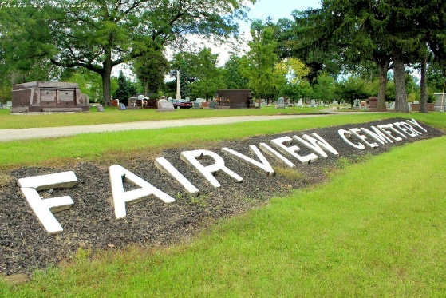
Photo by Tombstoner & Family

- Z. Rotharmel, 78, Succumbs After 2-Month Illness.

Albert Z. Rotharmel, 78, of 166 Wolfe avenue, died Wednesday at General hospital following an eight-week illness. Born April 1, 1862, in Canada. Mr. Rotharmel, a retired tailor, had been a resident of Mansfield 26 years.
Surviving are two daughters, Mrs. T. O. Grisell of Bradford, Pa., and Mrs. Mary Silvers of Birmingham, Ala., and two sons, Kenneth Rotharmel of New Orleans, La., and Martz Rotharmel of Birmingham, Ala.
The body was removed to the Wappner funeral home. Funeral arrangements are incomplete.

Mansfield News Journal, Richland County, Ohio
May 8, 1940
**

ROTHARMEL

Bluffton, May 8 – Word was received here of the death this morning at Mansfield, O., of Albert Rotharmel, 70, a former resident of this city. He was a tailor by trade and served one term as deputy county clerk 40 years ago.
Surviving are two sons, Kenneth of New Orleans, La., and Martz of Birmingham, Ala., and two daughters, Mrs. Thomas O. Grissell of Bradford, Pa., and Mrs. Mary Silver of Birmingham, Ala.
The body will be returned here for burial in Fairview Cemetery.

Journal-Gazette, Allen County, Indiana
May 9, 1940
**
Indiana, U.S., Marriage Certificates, 1960-2012
Name Albert Z Rotharmel
Gender Male
Marriage License Date 30 Nov 1887
Marriage Date 30 Nov 1887
Marriage Place Wells, Indiana, USA
Spouse Eva E Martz
Officiator G G Copland

