Marguerite Evelyn (Zinn) Roth
June 7, 1919 – December 16, 2004

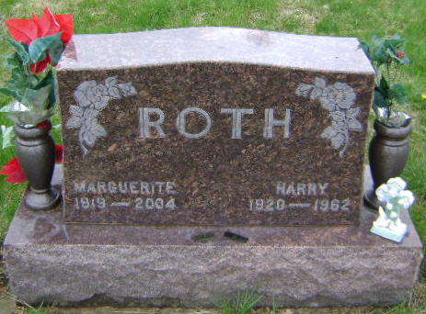
Photo by Bruce Sonner
Former Bluffton resident Marguerite E. Roth, 85, Columbia City, died at midnight, Thursday, Dec. 16 at Miller's Merry Manor in Columbia City. Born in Dixon, Ohio on June 7, 1919 to Clarence and Rose Ellen Beatty Zinn, she married Harry Roth on Nov. 6, 1943 in Fort Wayne; he died. Nov. 11, 1962. She worked at Franklin Electric in Bluffton for 19 years, retiring in 1987.
Survivors include two daughters, Jackie Roth of Ossian and Mr. James (Sheryl) Hedges of Fort Wayne; a son, Jerry Roth of Columbia City; five grandchildren; and two great grandchildren.
Services will be held Saturday at 10:30 a.m. at Goodwin Memorial Chapel in Bluffton, with Rev. Chad Clark officiating. Visitation hours are today from 2 to 8 p.m. Burial will be in Fairview Cemetery.
Bluffton News-Banner, Wells County, Indiana
Friday, December 17, 2004

