Harry Roth
May 8, 1920 – November 11, 1962

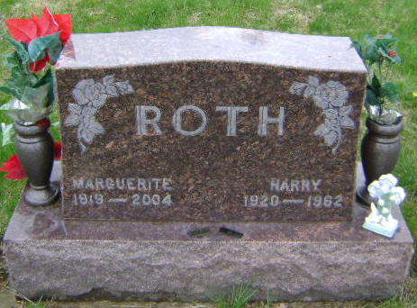
Photo by Bruce Sonner

Harry Roth Is Taken By Death Sunday Morning
Rites Wednesday For Monroe Tp. Native, 42

Harry Roth, 42, of Murray, a native of this community died at 11 a.m. Sunday in the Wells County hospital in Bluffton following an illness of seven years. During these years Roth was in and out of the hospital many times for treatment and had been in a serious condition several months. He was admitted to the hospital for the last time a week ago today after spending several weeks at home following long hospitalization.
Roth was born in Monroe township May 8, 1920, the son of Jacob and Eliza Liechty Roth. He was married to Marguerite Zinn, Nov. 6, 1943, at Fort Wayne. Roth was employed for many years at the Decatur Casting Company. He and his family resided in the Bluffton area the last 10 years.
Surviving are the wife; a son, Jerry and two daughters, Sheryl Ann and Jacqueline Sue, all at home; a brother Vilas, Fort Wayne and seven sisters, Mrs. Dennis (Silva) Lantz, Mrs. Alva (Golda) Smith and Mrs. Ida Gerber, all of Bluffton; Mrs. Mary Rich, Berne; Mrs. Melvin (Lula) Walchle, Geneva; Mrs. Martin (Lucinda) Walchle, Preble, and Mrs. Gerald (Rose) Liby, Fort Wayne. Six brothers and a sister preceded in death.
The body is at the Goodwin Funeral home in Bluffton where friends may call after 7 p.m. today. Services will be held at the funeral home at 2 p.m. Wednesday, Rev. John Trusdale and Rev. Keith Davis officiating. Burial will be in Fairview cemetery at Bluffton.

Berne (IN) Library Heritage Room
Adams County Obits 1962-1964
Monday, Nov. 12, 1962
**

BLUFFTON—Harry Roth, 42, died Sunday in Wells county hospital. Surviving are his wife. Marguerite; one son, two daughters, seven sisters and one brother. Rites at 2 p.m. Wednesday in the Goodwin Funeral Home.

Berne (IN) Public Library Heritage Room
Adams Co. Obits 1962-64
Tuesday, Nov. 13, 1962

