James L. Roberts
May 6, 1935 – May 23, 2024

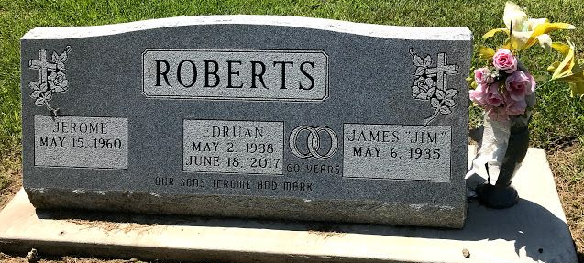
Photo by SMMR

James L. Roberts, 89 of Bluffton, passed away on Thursday morning, May 23, 2024, at Markle Health & Rehab Center. Jim was born on May 6, 1935 in Wells County to Joe and Bernice (Jackson) Roberts. He was a lifelong resident of Wells County and attended Bluffton High School. He was a custodian at Bluffton Elementary School for 24 years, retiring in 1997. He was a member of Epworth United Methodist Church.
On April 20, 1957, Jim and Edruan Porter were married in Liberty Center. They shared 60 years of marriage before her passing in 2017.
Jim is survived by two sons; Jerome Roberts of Markle and Mark (Shellie Coons) Roberts of Albany, IN., and a grandson Rhett Roberts.
Jim is preceded in death by his parents Joe and Bernice, his wife Edruan, and a brother Richard Roberts.
A service to celebrate Jim's life will be held at 11:00 A.M. on Tuesday, May 28, 2024 at the Thoma/Rich, Lemler Funeral Home in Bluffton. Tony Garton will officiate. Calling hours will be from 9 A.M. to 11 A.M., prior to the service on Tuesday at the funeral home. Burial will follow at Fairview Cemetery in Bluffton.
Memorials may be made to Epworth United Methodist Church or Bi-County Services.
Thoma/Rich, Lemler Funeral Home, Wells County, Indiana

