Jane S. (Parker) Rinear
May 18, 1820 – April 6, 1894

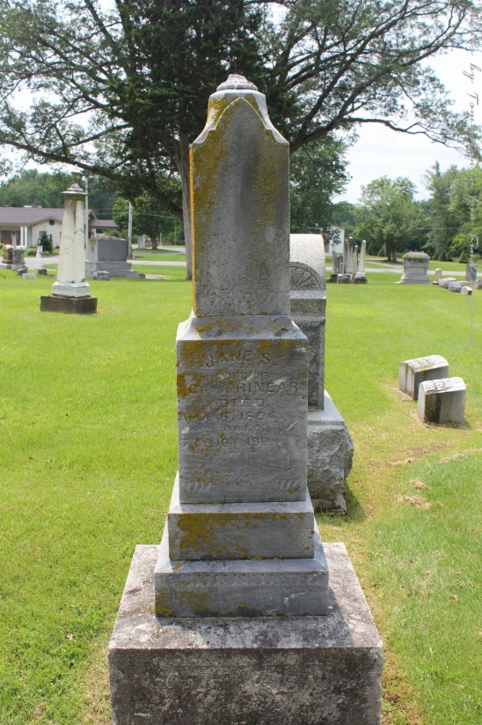
Photo by Tombstoner & Family

DOUBLE FUNERAL
Jane S. Parker Rinear and Ezra Crozedale [sic]

A double shadow of sorrow has fallen across this community. On last Friday evening about nine o'clock the death messenger came to two old respected citizens of this place and called from their earthly work to their heavenly reward Jane S. Parker Rinear and Ezra Crozdale [sic]. This event was not unexpected by them or their friends. Both of the deceased had been invalids for years and had been very low for several weeks. They were pioneers of the county and belonged to two of our best known and most respected families of the township.
They were nearly of the same age and both had lived a life of childlike simple faith in the Son of God. Their funerals were preached at the same hour (ten o'clock) Sunday morning at the Liberty Center Baptist church by Rev. C. S. Winans in the presence of a large congregation of sympathizing neighbors and friends.
The following are the obituaries of each:
Jane S. Parker Rinear was born in Genesee County, New York, May 17, 1820. She came with her parents to Cuyahoga County, Ohio, when but ten years of age; here she remained until the time of her marriage with Charles Rinear after which they came to Indiana May 1, 1847.
In the summer of 1855, she with her husband and a few others became the constituent members of the Liberty Baptist church which was organized within one hundred feet of her late home. She had, however, been converted and was a member of the church when but a little girl. She was a devout and faithful member of this church up to and at the time when she bid adieu to the church militant to join the church triumphant. Although she was unable for several years on account of feeble health to attend the church, yet as she said to the writer she had a time and a place every day to remember the church in prayer. She bore the long years of physical suffering with that patient resignation born of faith in the Son of God. She had the end of life fully in view and was prepared to meet the summons at its coming.
She was a kind, patient mother, always devoted to her home and family. She had been an invalid for years. On January 8th, she received a fall which kept her confined to her bed until the death messenger came to call her home April 6, 1894, aged 73 years, 10 months and 19 days.
She was the mother of James W. Rinear, Elias M. Rinear, the county commissioner, Mrs. Eli Smith, Mrs. Henry Johnson, George Rinear, and Charles A. Rinear. The latter, with her husband, having preceded her to the eternal world. The sermon was preached from Philipians 1-21: "For me to live is Christ, and to die is gain." Interment in Fairview cemetery in Bluffton.
Ezra C. Crozedale<snip>

Bluffton Banner, Wells County, Indiana
(a weekly newspaper)
Wednesday, April 11, 1894

