Isaac Wilson Ridenour
February 16, 1876 – May 14, 1912

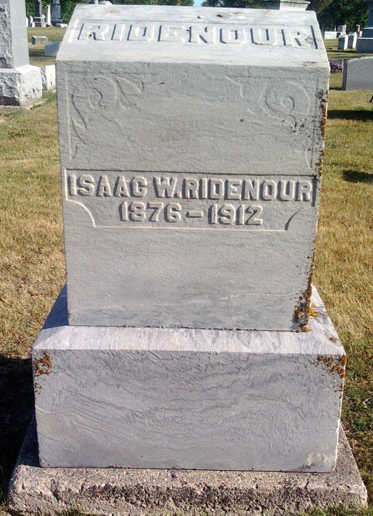
Photo by Thomas Liby

INHERITED FORTUNE, DIED OF APOPLEXY

BLUFFTON, Ind., May 12 - Isaac W. Ridenour, 46, was found dead in bed this morning by his wife between the hours of 2 and 4. The coroner's inquest shows that death was due to apoplexy.
Mr. Ridenour had recently inherited $12,000 from the estate of his father. He had been a resident of Bluffton only three months at this time, although he resided in the city for some time about six years ago.

Berne Witness, Adams County, Indiana
Tuesday, May 14, 1912
**

Indiana, U.S., Death Certificates, 1899-2017
Name Isaac Wilson Ridmour
Gender Male
Race White
Marital Status Married
Age 36y 2m 24d
Birth Date 16 Feb 1876
Birth Place Indiana
Death Date 12 May 1912
Death Place Bluffton, Wells, Indiana, USA
Death Registration Date 1912
Father Adam Ridmour
Mother Sarah Wilson
Spouse Ida Shelly/Shelby Ridnour, informant
Burial Fairview date illegible
**
Indiana, U.S., Marriage Index, 1800-1941
Name Isaac Ridenour
Gender Male
Marriage Date 3 Apr 1897
Marriage Place Clinton, Indiana, USA
Spouse Name Anna Sleeper

