Lona (Merriman) Reynolds
January 22, 1875 – April 20, 1955

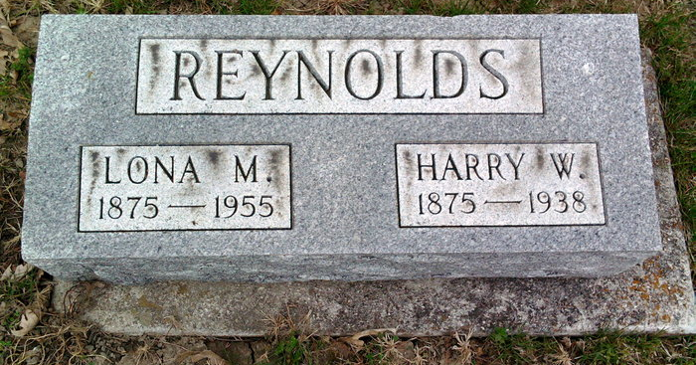
Photo by Thomas Liby

MOTHER OF PETE REYNOLDS IS DEAD
SERVICES HELD TODAY AT BLUFFTON FOR 80- YEAR-OLD

Mrs. Lona M. Reynolds, 80, mother of Pete Reynolds of Decatur, died suddenly at 4:20 o’clock Wednesday morning at the Clark Nursing Home in Bluffton, where she had resided for the past few years. Although not in the best of health for a number of years, her death was unexpected, and followed a stroke suffered early Tuesday evening.
She was born in Apple Creek, O., Jan. 22, 1875, a daughter of A. W. and Nancy Neuenschwander-Merriman, but had resided in Bluffton practically her entire life. Her husband, Harry W. Reynolds, was killed in a traffic accident north of Bluffton more than 17 years ago.
Mrs. Reynolds was a member of the First Baptist Church in Bluffton and for many years was a member of the church choir and also served as church organist.
Surviving in addition to the son in Decatur are two other sons, W. G. Reynolds of York, Pa., and Max E. Reynolds of Detroit, Mich.; seven grandchildren; two great-grandchildren; one brother, Ward H. Merriman of Detroit, Mich., and one sister, Mrs. Morna Fox of Indianapolis. One daughter and two brothers are deceased.
The funeral was held this afternoon at the First Baptist Church in Bluffton with Rev. H. Carlton Atwater officiating. Burial was in Fairview Cemetery.

Adams County (IN) Historical Museum
1955 March-April 1958 Scrapbook, image 7
Handwritten- Fri. April 22, 1955
**

Indiana, U.S., Death Certificates, 1899-2011
Name: Lona Merriman Reynolds
[Lona Merriman Merriman]
Gender: Female
Race: White
Age: 80
Marital status: Widowed
Birth Date: 22 Jan 1895 (sic)
Birth Place: Ohio
Death Date: 20 Apr 1955
Death Place: Bluffton, Wells, Indiana, USA
Father: A W Merriman
Mother: Nancy Neuenschwander
Informant: Pete Reynolds; Decatur, Indiana
Burial: April 22, 1955; Fairview Cemetery; Bluffton, Indiana

