Harry W. Reynolds
December 25, 1875 – November 21, 1938

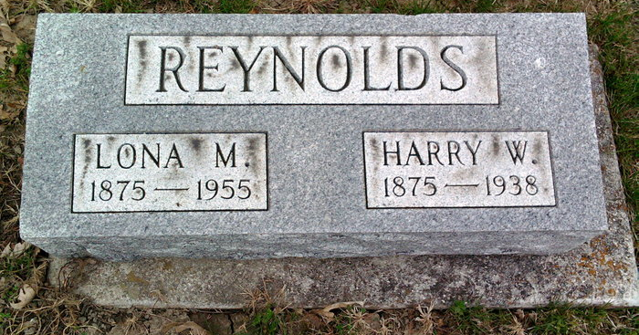
Photo by Thomas Liby

CYCLIST KILLED NEAR BLUFFTON
Harry Reynold, 62, Hit by Auto
BLUFFTON, Nov. 21 - Harry W. Reynolds, 62, well-known Bluffton man and former teacher, in the Wells county schools, was killed instantly at 6:15 p.m. tonight when the bicycle he was riding was struck by an automobile driven by Dallas Claude Cole, 35, of Muncie, half a mile north of this city on state road 1.
Cole told Coroner William McBride and City Officer True Shepard that he did not see the cyclist and was not aware of him until the moment of the impact. The right front fender of the car struck the bicycle, and Reynolds' body was thrown against the windshield and then tossed to the right of the pavement. The top of the skull was crushed.
Cole notified the coroner and police from a nearby residence and then went to police headquarters to make a report. He was not held. McBride said his verdict would be accidental death.
Surviving are the widow, formerly Miss Lona Merriman; three sons, Doyle(Pete) Reynolds, city editor of the Decatur Daily Democrat, Wilbert Reynolds of Decatur, Ill., and Max Reynolds of Greencastle; one brother, J. Edwin Reynolds of Bluffton, and one sister, Mrs. Arla Poland of Detroit.
The body was taken to the Thoma and Son funeral home. Services have not been arranged.

Journal Gazette; Allen County, Indiana
November 22, 1938

