Lulu M. (Jahn) Ratliff-Beehler
March 1, 1890 – October 30, 1989

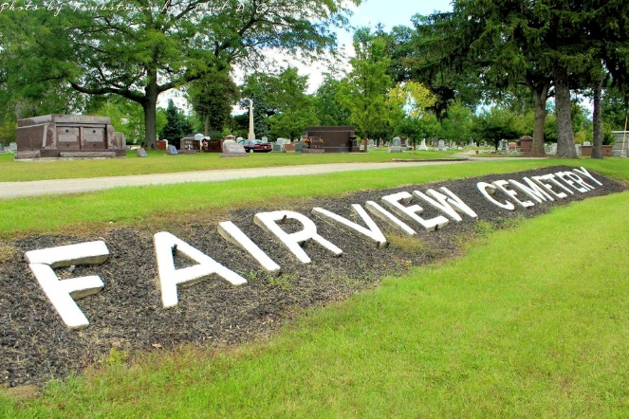
Photo by Tombstoner & Family

Lulu M Beehler
in the Indiana, U.S., Death Certificates, 1899-2017

Name Lulu M Beehler
[Lulu M Jahn]
Gender Female
Race White
Marital Status Widowed
Age 99
Birth Date 1 Mar 1890
Birth Place Adams County
Death Date 30 Oct 1989
Death Place Berne, Adams, Indiana, USA
Death Registration Date 1989
Father Marcus Jahn
Mother Elizabeth Longenberger
Informant Mark R. Jahn; nephew; Decatur, Indiana
Burial November 1, 1989; Fairview Cemetery; Bluffton, Indiana

