Ollie Puckett Jr.
September 30, 1962 – May 21, 2011

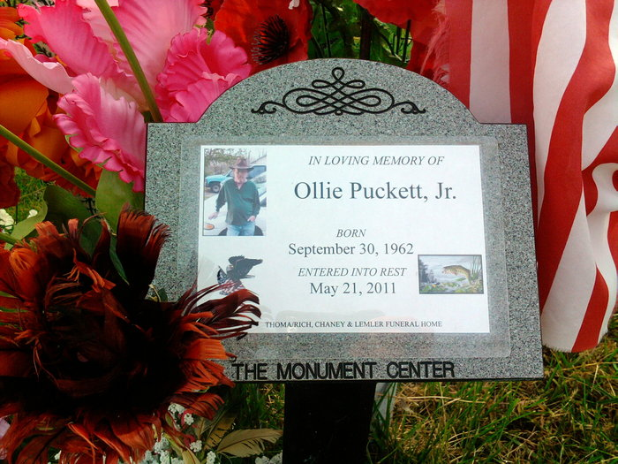
Photo by Thomas Liby

Ollie Puckett Jr., 48, of Bluffton, died Saturday, May 21, 2011, at his residence. Mr. Puckett was born in Winamac on September 30, 1962, to Ollie and Emma Jean (Tunis) Puckett Sr.
Ollie attended Southern Wells schools. He served in the U.S. Army for one year and worked for Waste Management for 15 years. He attended Bluffton Church of God. He greatly enjoyed fishing and will be remembered as a very hard worker.
Surviving relatives include, four daughters, Amber Eltzroth of Bluffton and Fawntasha, Kalesha and Lakeela Puckett, all of Bluffton; one son, Ollie H.D. Puckett of Bluffton; two sisters, Emma Fay Puckett and Sandra Dee Manns of Bluffton; two brothers, Troy Dean Puckett of Decatur and Ervin Donald Puckett of Nashville, Tenn.; and one granddaughter.
He is also survived by his fiancé, Carol Shearer of Huntington; and caretakers, Charles and Mollie Rudd of Bluffton.
Mr. Puckett was preceded in death by one son, Ollie Puckett III.
Calling hours will be from 12:30 to 2:30 p.m. Wednesday, May 25, at the Thoma/Rich, Chaney and Lemler Funeral Home in Bluffton. Funeral services will be at 2:30 p.m. Wednesday, at the funeral home with Pastor Don Marlowe of the Bluffton Church of God officiating. Burial is at Fairview Cemetery, in Bluffton. Preferred memorials are to the family.

Thomas/Rich, Lemler Funeral Home, Wells County, Indiana

