Lee Ola “Eola” (Cates) Puckett
November 13, 1934 – June 8, 2014

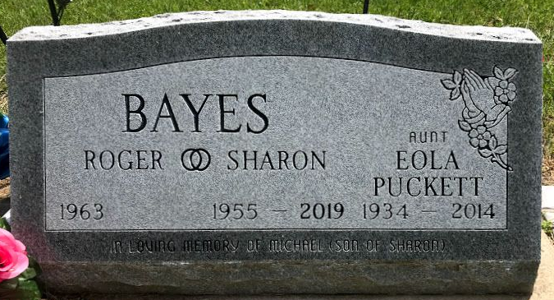
Photo by SMMR

Lee Ola Puckett, 79 of Fort Wayne passed away at 5:45 a.m. Sunday, June 08, 2014 at Woodview Healthcare in Fort Wayne, Indiana.
Mrs. Puckett was born on November 13, 1934 in San Angelo, Texas to Charlie E. & Matti L. (Holloway) Cates. She shared 43 years with her husband, James Puckett and he preceded her in death on May 8, 2001.
Growing up in Texas, she worked harvesting cotton and vegetables. She also worked as a cooking assistance at Campbell Memorial Hospital in Texas for many years. She attended the Three Rivers Wesleyan Church in Fort Wayne.
She is survived by a niece Sharon (husband Roger) Bayes of Fort Wayne along with several nieces & nephews and some great-nieces and nephews. She is also survived by a step-son James Puckett of Weatherford, Texas.
She is preceded in death by a brother Jackie Cates and a sister Deloris Burkes and several step-brothers and sisters.
Funeral Services will be held at 4:00 p.m. on Wednesday, (June 18, 2014) at the Thoma/Rich, Lemler Funeral Home in Bluffton. Pastor Larry Maddock will officiate. Burial will follow at Fairview Cemetery in Bluffton. Memorials may be made to the American Cancer Society.

Thoma/Rich, Lemler Funeral Home, Wells County, Indian

