Xander E. Powers
April 14, 2011 – July 30, 2011

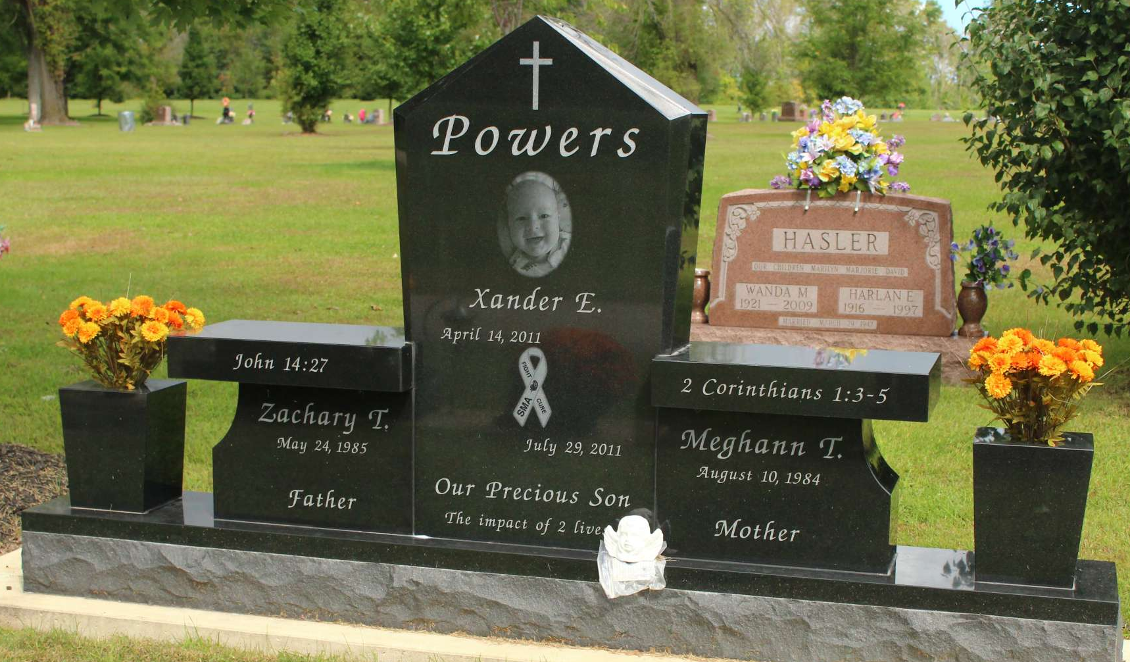
Photo by Tombstoner & Family

Three month old Xander E. Powers of Ossian, passed away at 10:47 a.m. Friday, July 29, 2011 at Lutheran Hospital. Xander passed away with complications from Spinal Muscular Atrophy, which is a neo-muscular genetic disorder.
He was born on April 14, 2011 to Zachary T. and Meghann T. (Kenline) Powers; they survive and reside in Ossian. Xander is also survived by grandparents, Sheryl A. Powers of Zanesville, Kim and Janice Kenline of Ossian, John F. Powers of Fort Wayne; Great-grandparents, James and Delenia Peeper of Bluffton, Rev. Bruce W. Kenline of Bluffton, Margaret Powers of Fort Wayne, Thomas and Helen Langmeyer of Fort Wayne; aunts and uncles, Abbey and Ryan Mooney of Westfield, Indiana, Kathryn Kenline of Studio City, California, Ryan Powers of Zanesville, Indiana, and by several great aunts and uncles.
Xander was preceded in death by an uncle, Evan Powers on September 22, 2005 and by a Great-grandmother, Jeannette A. Kenline on May 29, 2011.
Calling hours are Noon to 8:00 p.m. on Tuesday, August 2, 2011 at Thoma/Rich, Chaney & Lemler Funeral Home in Bluffton. A service celebrating Xander's life will be conducted at 10:00 a.m. Wednesday, August 3, 2011 at Hope Missionary Church with Pastor Matt Hartsell officiating. There will also be calling one hour prior to the service at the church. Burial will be in Fairview Cemetery.
Preferred memorials are to Families of Spinal Muscular Atrophy or Kate's Kart.

Thoma/Rich, Lemler Funeral Home, Wells County, Indiana
**

POWERS, XANDER E.: A service celebrating Xander's life is 10 a.m. today, Aug. 3, 2011, at Hope Missionary Church, with calling one hour prior to the service. Arrangements by Thoma/Rich, Chaney & Lemler Funeral Home, Bluffton.
Fort Wayne Newspapers, Allen County, Indiana
August 1 to August 3, 2011

