Ruth V. (Foust) Poffenberger
January 26, 1879 – May 14, 1955

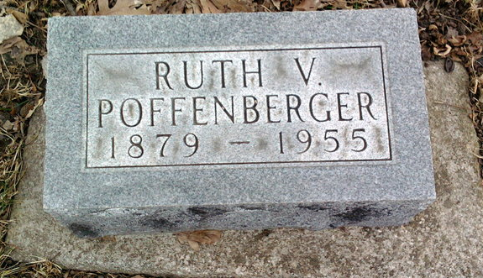
Photo by Thomas Liby

Indiana, U.S., Death Certificates, 1899-2017

Name Ruth Poffenberger
Gender Female
Race White
Marital Status Widowed
Age 76
Birth Date 26 Jan 1879
Birth Place Indiana
Death Date 14 Jun 1955
Death Place Rural, Wayne, Indiana, USA
Death Registration Date 1955
Father Fred Foust
Mother Rebecca Parfect
Informant Richmond State Hospital Records
Burial 5/17/1955 Fairview Cemetery
**
Indiana, Marriages, 1810-2001

Name Ruth W Foust
Gender Female
Race White
Event Type Marriage Registration (Marriage)
Birth Place Wells, Indiana
Marriage Date 13 Mar 1895
Marriage Place Bluffton, Indiana, United States
Residence Place Bluffton, Indiana
Father Fred Foust
Mother Rebecca Perfect
Spouse George H Poffenberger
Page 180

