George Henry Poffenberger
September 14, 1867 – January 28, 1940

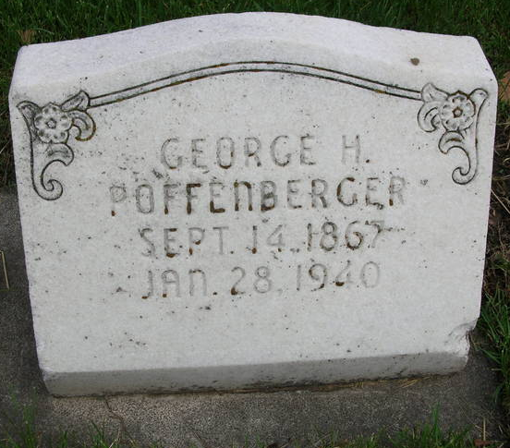
Photo by David Blackford

POFFENBERGER

Bluffton, Jan. 28 – George H. Poffenberger, 72, lifelong resident of Bluffton, a cigar maker by trade, died at 11 am today at his home.
He had been in ill health for three years.
Surviving is the widow, Ruth, and a brother, John of this city.
Mr. Poffenberger was a member of the First Baptist Church.
Funeral services will be held at 2 pm Tuesday at the funeral home of McBride & Son, in charge of Rev. Morris H. Coers. Burial will be in Fairview Cemetery.

Fort Wayne Journal-Gazette, Allen County, Indiana
January 29, 1940
**

Indiana, U.S., Death Certificates, 1899-2017
Name George H Poffenberger
Gender Male
Race White
Marital Status Married
Age 72y 4m 4d
Birth Date 14 Sep 1867
Birth Place Bluffton, Indiana
Death Date 28 Jan 1940
Death Place Bluffton, Wells, Indiana, USA
Father John Poffenberger
Mother Jane Harbaugh
Spouse Ruth Foust Poffenberger, age 62; informant
Burial 1-30-1940 Fairview Cem

