Roger Pfeifer
July 27, 1913 – February 29, 1988

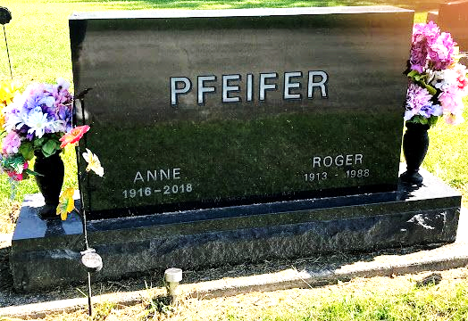
Photo by SMMR

Indiana, U.S., Death Certificates, 1899-2017
Name Roger Pfeifer
Gender Male
Race White
Marital Status Married
Age 74
Birth Date 27 Jul 1913
Birth Place Veracruz, Indiana
Death Date 29 Feb 1988
Death Place Bluffton, Wells, Indiana, USA
Death Registration Date 1988
Father Jacob Pfeifer
Mother Emma Reppert
Spouse Anne Vernette Pfeifer, informant
Burial 3/3/1988 Fairview Mausoleum

