Anne (Vernette) Pfeifer
April 9, 1916 – February 12, 2018

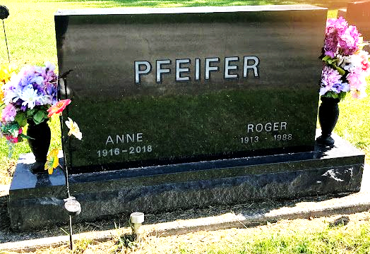
Photo by SMMR

Anne Pfeifer, 101, of Bluffton passed away Monday morning, February 12, 2018, at Christian Care Retirement Community in Bluffton.
She was born on April 9, 1916 in Pierceton, Indiana to Lewis & Elizabeth (Steinman) Vernette. Anne graduated from Pierceton High School in 1934 and from International Business College in 1935. On June 29, 1956 in Fort Wayne, Roger & Anne were married. They shared 32 years together before he preceded her in death on February 29, 1988.
Anne worked with Roger on the family farm for many years and was a talented seamstress. She was a member of First Presbyterian Church in Bluffton, where she served as an Elder and Deacon. She served as the past president and member of the Poplar Grove Extension Homemaker Club for many years.
Survivors include her children: Luanne (David) Brown of Zanesville, Peggy (Art) Schwartz of Fort Wayne, Sue (Neil) Pierce of Salisbury, NC and Ted Pfeifer of Lititz, PA, along with 8 grandchildren and 19 great-grandchildren and 3 great-great-grandchildren.
She is preceded in death by two sisters Charlotte Cormany and Mary Logan.
A service to celebrate Anne’s life will be held at 10:30 A.M. Friday (Feb. 16th) at the Thoma/Rich, Lemler Funeral Home in Bluffton with Jeff Lemler officiating. Friends are encouraged to wear Anne’s favorite color purple to her service. Calling hours will be from 2 to 8 on Thursday at the funeral home and for one hour prior to the service. Burial will follow at Fairview Cemetery in Bluffton.
Memorials may be made to Christian Care Retirement Community..
Thoma/Rich, Lemler Funeral Home, Wells County, Indiana
February 12, 2018

