Andrew H. Penrod
August 27, 1859 – September 9, 1920

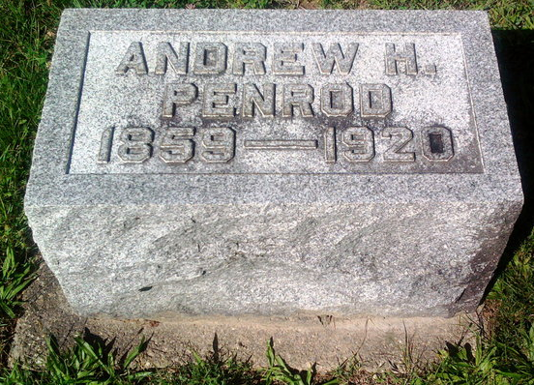
Photo by Thomas Liby

Bluffton Ind., Sept 9. - Word was received here today of the death of Andrew H. Penrod, 61, of New Lexington, O., formerly of this city. He died yesterday at Winchester, Ind., at the home of a son, Theodore Penrod, where he became ill while en route home from a visit in this county.
Surviving are the following children: William of Muncie; Theodore, Winchester; Floyd Penrod and Mrs. Abram Ernst, Bluffton. Five brothers are: Samuel of Montpelier, and Joe, Chester, Robert and John, near Poneto.
The body was brought here today to the home of Mrs. Ernst, and the funeral will be held Friday afternoon at 2 o'clock at the Reformed church.
The Fort Wayne Journal-Gazette (Allen County, Indiana)
Friday, Sep. 10, 1920
**

Indiana, U.S., Death Certificates, 1899-2017
Name Andrew H Pensod
[Andrew H Penrod]
Gender Male
Race White
Marital Status Widowed
Age 61
Birth Date 27 Aug 1859
Birth Place Indiana
Death Date 8 Sep 1920
Death Place White River, Randolph, Indiana, USA
Father Andrew T. Pensod
Mother Joanna Pace
Informant faded Winchester
Burial Bluffton, Ind 9/12/1920

