William Alexander Patton
February 24, 1875 – April 22, 1953

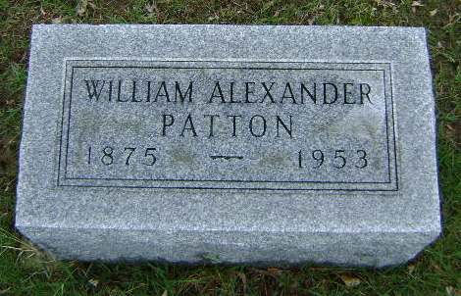
Photo by Bruce Sonner

William Patton, 78, Dies at Bluffton

Bluffton, April 23 – William A. Patton, 78, a retired furniture manufacturer, died at 11 pm yesterday in the Clinic Hospital, where he had been a patient four weeks.
Mr. Patton, long ill, was a native of Porter County, but had resided here since 1910. From 1910 to 1914, Mr. Patton was secretary and general manager of the Bluffton office of the United Telephone Company and for the following two years was secretary and general manager of the Marion & Bluffton Traction Company. He was secretary and general manager of the W. & B. Brown Chandelier Company the next seven years.
In 1923, Mr. Patton became the senior partner in the Patton-McCray Manufacturing Company. The business was dissolved when Mr. Patton retired.
Surviving are two daughters, the Misses Minnie Elizabeth and Edwina Patton, this city.
The body is at the Thoma Funeral Home, where services will be conducted at 9:00 am, the Rev. Matthew Worthman officiating. Burial will be in Fairview Cemetery.

Journal-Gazette, Allen County, Indiana
April 24, 1953
**

Indiana, U.S., Death Certificates, 1899-2017
Name William R Patton (indexed as Pation)
Gender Male
Race White
Marital Status Widowed
Age 78
Birth Date 24 Feb 1875
Birth Place Indiana
Death Date 22 Apr 1953
Death Place Bluffton, Wells, Indiana, USA
Death Registration Date 1953
Father Joseph Porton
Mother Sarah Leoch
Informant Elizabeth Porter/Patton
Burial 4/25/1953 Fairview
**

Indiana, U.S., Marriage Index, 1800-1941
Name William A. Patton
Marriage Date 7 May 1903
Marriage Place Wells, Indiana, USA
Spouse Name Stella Vaughn

