Stella Adelia (Vaughn) Patton
July 30, 1876 – February 18, 1952

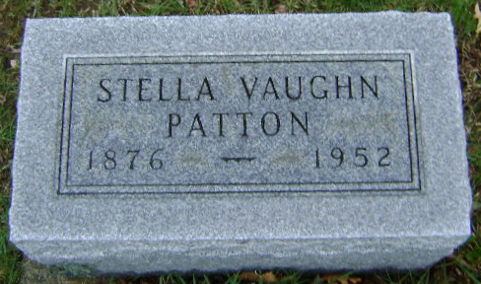
Photo by Bruce Sonner

Indiana, U.S., Death Certificates, 1899-2017
Name Stella Vaughn Patton
[Stella Vaughn Vaughn]
Gender Female
Race White
Marital Status Married
Age 75
Birth Date 30 Jul 1876
Birth Place Indiana
Death Date 18 Feb 1952
Death Place Bluffton, Wayne, Indiana, USA
Death Registration Date 1952
Father Edwin C Vaughn
Mother Sarah Gastel/Trostel
Informant William A. Patton
Burial 2/20/1952 Fairview Cemetery

