Sarah A. (Duer) Patterson
June 26, 1848 – January 30, 1935

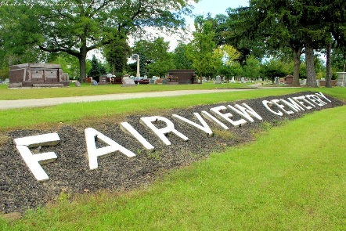
Photo by Tombstoner & Family

LOCAL MAN'S MOTHER DIES
Mrs. Sarah Patterson is Dead; Dad's Restaurant Closed Friday

Mrs. Sarah A. Patterson, aged ??, mother of R. C. Patterson of Berne and proprietor of Dad's Restaurant here, died at 8:15 o'clock Wednesday evening at the Methodist hospital at Fort Wayne. Mrs. Patterson fractured a hip in a ?? several weeks ago, and had been confined to the hospital since. Her condition had been critical for some time. She also suffered from heart trouble.
Mrs. Patterson was born in Wells county on June 11, 1848, and most of her life was spent in Bluffton. Surviving are one son, R. C. Patterson of Berne, and one daughter, Mrs. C. F. Brown of Fort Wayne. ?? grandchildren survive, including Earl and Lavere Patterson. The funeral will be held Friday afternoon at 2 o'clock from the Thoma funeral home at Bluffton. Burial will be in Fairview cemetery in that city.
The restaurant here operated by ?? and Lavere Patterson will be closed Friday from 10 o'clock in the morning until 3:30 in the afternoon.

Adams County Historical Museum
1935 Scrapbook, image 08
Handwritten date: Thursday, Jan. 31, 1935
**

Indiana, U.S., Death Certificates, 1899-2017

Name Mrs Sarah Patterson (indexed as Pattirson)
[Mrs Sarah Duer]
Gender Female
Race White
Marital Status Married
Age 85y 7m 4d
Birth Date 26 Jun 1849
Birth Place Ohio
Death Date 30 Jan 1935
Death Place Fort Wayne, Allen, Indiana, USA
Father Jacob Duer
Mother Mildred ?? Duer
Spouse Robert Patterson
Informant Mrs. G. T. Drumm?
Burial illegible 1/30/1935
**
Sarah A Durr from tree Danielle Meyer-VonBank Family Tree
Birth 26 Jun 1848 Ohio, USA
Marriage 18 Nov 1869 Bluffton, Wells, Indiana, USA
Residence 1900 Wells, Indiana, USA
Death 30 Jan 1935 Wells, Indiana, USA
Father Jacob Durr (1823-1880)
Mother Malinda (1824-1902)
Spouse Robert Patterson (1841-1919)
656 People 4 Records 8 Sources
**
Indiana, U.S., United Methodist Church Records, 1837-1970
Name Sarah A Durr
Event Type Marriage
Marriage Date 18 Nov 1869
Marriage Place Bluffton, Indiana, USA
Gender Female
Spouse Robert Patterson

