Rachel Ophelia (Lee) Park
April 5, 1860 – December 3, 1914

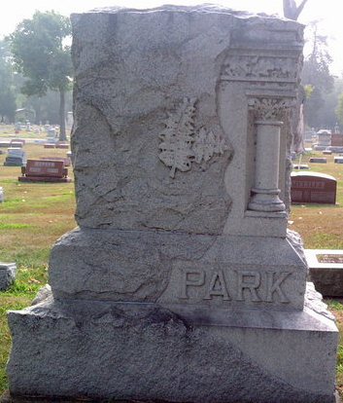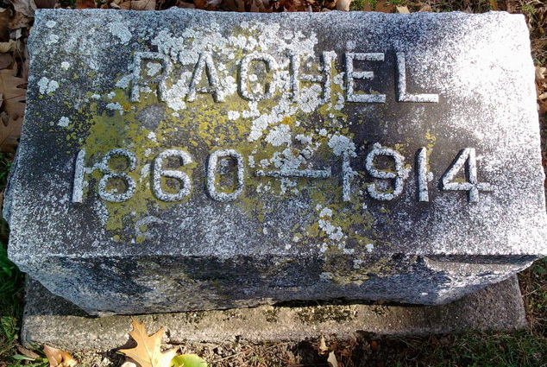
Photos by Thomas Liby

Indiana, U.S., Death Certificates, 1899-2017
Name Racheal Ophelia Lee Park
[Racheal Ophelia Lee Lee]
Gender Female
Race White
Marital Status Married
Age 54
Birth Date 5 Apr 1860
Birth Place Wells County, Indiana
Death Date 3 Dec 1914
Death Place Bluffton, Wells, Indiana, USA
Death Registration Date 1910-1919
Father John Lee
Mother Sophia Galayda
Spouse Matthew Park, informant
Burial Fair View 12-5-1914
**
Indiana, U.S., Marriages, 1810-2001
Name Rachel O Lee
Gender Female
Event Type Marriage Registration (Marriage)
Marriage Date 28 Dec 1881
Marriage Place Indiana, United States
Spouse Matthew J Park
Page 115
FHL Film Number 002318462

