Matthew J. Park
January 26, 1853 – April 19, 1940

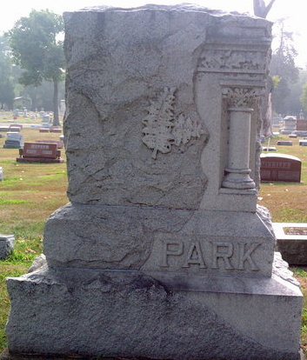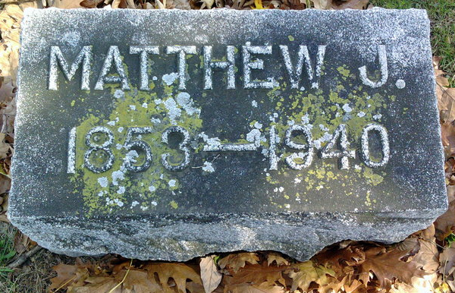
Photos by Thomas Liby

PARK

Bluffton, April 20 - Matthew J. Park, 87, a native of Wells County since he was three years of age, when he was brought to this country with his parents from Ireland, died last night at his home five miles northwest of Bluffton, following an illness of six weeks. His entire life was spent on a farm.
Surviving are three sons, John C. Park of Kankakee, Ill., Harold Park of Rockcreek Township and Archie Park of Harrison Township; five grandchildren and a great-grandson.
Funeral services will be held at 10:30 am Monday at the Uniondale Methodist Church, of which Mr. Park was a member. Burial will be in Fairview Cemetery.

Journal-Gazette, Allen County, Indiana
April 21, 1940
**

Indiana, U.S., Death Certificates, 1899-2017
Name Matthew J Park
Gender Male
Race White
Marital Status Widowed
Age 87y 2m 23d
Birth Date 26 Jan 1853
Birth Place Donegall Co Ireland
Death Date 19 Apr 1940
Death Place Bluffton, Wells, Indiana, USA
Father Matthew Park
Mother Jane Buchanan
Spouse Rachel Lee Park
Informant Harold Park
Burial 4/22/1940 Fairview
**
Matthew John Park from tree Elaine Welsh Fink family tree
Birth 26 Jan 1853 Sockar, Donegal, Ireland
Marriage 28 Dec 1881 Wells, Indiana, USA
Residence 1930 Bartholomew, Indiana, USA
Death 19 Apr 1940 Bluffton, Wells, Indiana, USA
Father Matthew Park (1810-1894)
Mother Jane Buchanan (1812-1900)
Spouse Racheal Ophelia Lee (1860-1914)
26046 People 15 Records 42 Sources

