Walter C. Oliver
February 13, 1897 – April 7, 1991

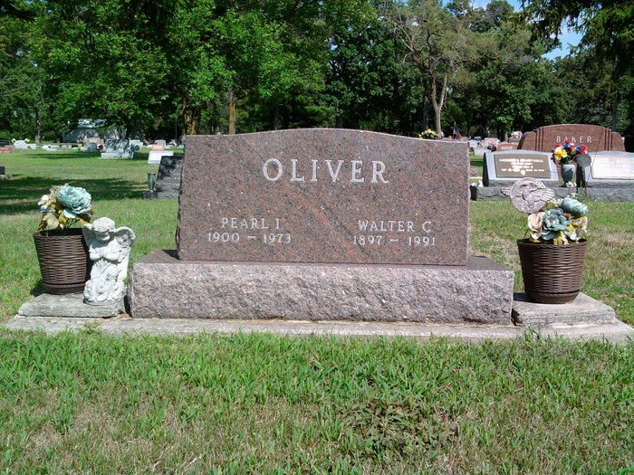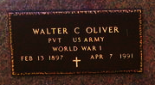
Photos by Thomas Liby

Walter C. Oliver, 94, Route 1, Monroe, died at 9:45 a.m. Sunday in U.S. Department of Veterans' Affairs Medical Center, Fort Wayne. He was born on February 13, 1897 in Monroe to Thomas B. and Mary A. Hocker Oliver and married Pearl I. Strickler on March 16, 1920. She died on September 23, 1973. He was a retired farmer and a veteran of the U.S. Army in World War I.
Surviving are a son, Franklin T. Oliver, route 1, Monroe; three daughters, Mrs. Carl (Jean) Hildebrand, Route 8, Decatur; Joan Workinger, 818 N. Third St.; Mrs. Paul (Janice) Hamrick, route 2, Monroeville; two brothers, Greg Oliver, Wewahitchka, Florida, and John Oliver, Auburn, California; two sisters, Francille G. Keller, Rockford, Ohio, and Lucille Baker, Fort Wayne; 14 grandchildren and 19 great-grandchildren. One son, Frederick Oliver; three sisters; and one great-granddaughter are deceased.
Funeral services are at 11 a.m. Wednesday in Haggard and Armes Funeral Home, Rev. James Hook officiating. Burial will be in Fairview Cemetery, Bluffton, with military graveside rites by American Legion Post 43, Decatur. Pallbearers will be Rex Oliver, Jim Oliver, Bill Crone, Terry Strahm, Mal Miesse, Dan Harman, Michael Reidenbach, and Brad Hamrick. Visiting hours at the funeral home are 2-9 p.m. Tuesday.

Decatur Daily Democrat, Adams County, Indiana
Monday, April 8, 1991

