Lowell Noe
August 25, 1906 – June 20, 1955

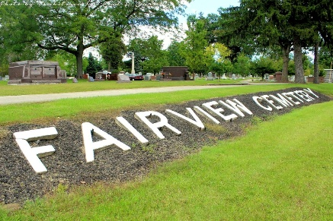
Photo by Tombstoner and Family

NOE, Lowell, 48, died Monday (June 20). Born Aug. 25, 1906, son of Oscar and Tunie Foster Noe. Married June 1, 1943 to Mildred Carnes. Survived by widow; three brothers, Carleton, Whitcomb and Woodrow. Fairview Cemetery.

Montpelier Herald, Blackford County, Indiana
Thursday, June 23, 1955, p1, c5
**

Indiana, U.S., Death Certificates, 1899-2017
Name Lowell Noe
Gender Male; Race White; Marital Status Married
Age 48
Birth Date 25 Aug 1906
Birth Place Indiana
Death Date 20 Jun 1955
Death Place Bluffton, Wells, Indiana, USA
Death Registration Date 1955
Father Oscar Noe
Mother Junie Foster
Informant not listed
Burial 6/22/1955 Fairview Cemetery

