Joyce A. (Tappy) Noble
October 21, 1942 – May 10, 2015

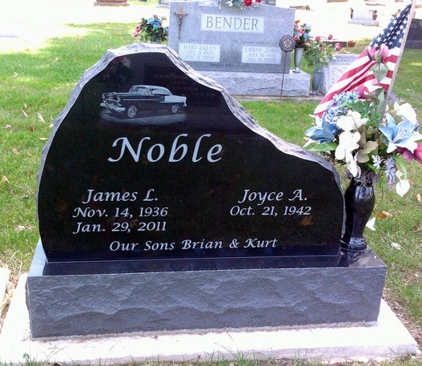
Photo by Thomas Liby

Joyce A. Noble 72 of Bluffton passed away at 9:35 a.m. Sunday, May 10, 2015, at Bluffton Regional Medical Center. Joyce was born on October 21, 1942 in Lima, Ohio to Kenneth E. & Frieda B. (Menden-hall) Tappy.
She graduated from Bluffton High School in 1960 and graduated from Warner Beauty College in 1961. On November 21, 1964 in Bluffton, Joyce and James L. Noble were married. He preceded her in death on January 29, 2011.
Joyce is survived by two sons: Brian K. ( Cathy ) Noble and Kurt L.
(Kimberly) Noble both of Bluffton along with grandchildren: Derek J. Noble and Alyssa K. Noble both of Bluffton, Kirtlyn M. Noble of Petroleum, IN and a great granddaughter Nataley M. Noble of Tampa, FL.
She is preceded in death by her parents, husband and a grandson Tyler J. Noble in 2012.
A private family service will be held at Fairview Cemetery in Bluffton. Memorials may be made in Joyce’s memory to Family LifeCare of Berne or Steve Kelly Cancer Relief Fund

Thoma/Rich, Lemler Funeral Home, Wells County, Indiana

