James Leon Noble
November 14, 1936 – January 29, 2011

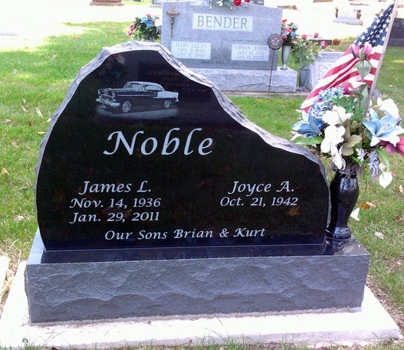
Photo by Thomas Liby

JAMES L. "JIM" NOBLE, 74, of Bluffton, passed away Saturday, Jan. 29, 2011, at Bluffton Regional Medical Center. Born to the late Marion A. and Luetta (Trout) Noble, Nov. 14, 1936, in Huntington County, Ind., he married Joyce A. (Tappy) Noble, Nov. 21, 1964; she survives.
He also served in the United States Army from 1959 through 1962. He retired from Habig Trucking after 25 years of service. After his retirement, he worked for NAPA Auto Parts in Bluffton.
He is also survived by children, Brian K. (Cathy) Noble of Bluffton and Kurt L. Noble of Bluffton; grandchildren, Tyler J. Noble of Tampa, Fla., Derek J. Noble of Bluffton, Alyssa K. Noble of Bluffton, Kirtlyn M. Noble of Petroleum, Ind.; great-grandchildren, Nataley M. Noble of Tampa, Fla.; sister, Glenna (Roger) Lee of Poneto, Ind.
He was preceded in death by a sister and brother, Wilma Smith and Charles Noble.
There will be no service. He will be interred privately at Fairview Cemetery. Arrangements by Thoma/Rich, Chaney & Lemler Funeral Home in Bluffton.

Fort Wayne Newspapers, Allen County, Indiana
January 30, 2011

