Irene (Howell) Newman
October 18, 1922 – April 19, 2016

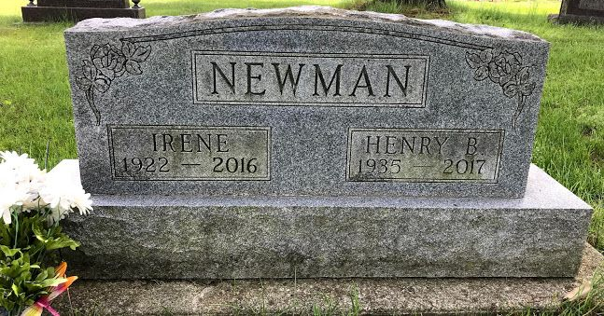
Photo by SMMR

Irene (Howell) Lee Newman 93 of Bluffton passed away on Tuesday (April 19, 2016) at Signature Health Care in Bluffton.
She was born to Blaine & Lelah (Foltz) Howell on October 18, 1922 in Grant County near Fairmount, Indiana. She graduated from Jefferson Township High School in Upland, Indiana in 1940. Irene married Ervin Lee in 1943 to them were born six children. He died on November 2, 1972. In 1986 she married Henry Newman. They attended the church in Kingsley Full Gospel near Dunkirk, Indiana until they moved to Bluffton where they attended Wesleyan Chapel Church.
She is survived by her husband Henry of Bluffton two sons James (Julia) Lee and Walter Lee and a daughter-in-law Jane White all of Montpelier, IN. Two daughters Janet (Don) Routledge of Wildersville, TN, Linda (Bill) Riggs of Greenfield, IN, along with four step-children: Donald (Carol) Newman, Judy (John) LaPeer and Brenda Thompson all of Bluffton. She is survived by 11 grandchildren, 8 step-grandchildren and several great-grandchildren and several step-great-grandchildren along with several nieces and nephews.
She is preceded in death by two sons Robert & Rex Lee and two brothers Herbert Howell and Rex Howell and a sister Frieda Thurston,
Funeral services will be held at 1:00 p.m. on Friday (April 22, 2016) at the Thoma/Rich, Lemler Funeral Home in Bluffton. Rev. Chad Clark will officiate. Burial will follow at Fairview Cemetery in Bluffton. Calling hours will be held from 3 to 8 on Thursday at the funeral home.
Thoma/Rich, Lemler Funeral Home, Wells County, Indiana
April 20, 2016

