Henry Bascom Newman
January 17, 1935 – November 12, 2017

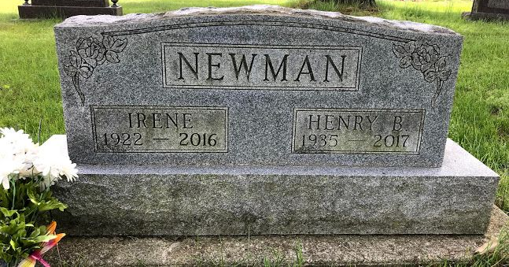
Photo by SMMR

Henry B. Newman, 82, of Bluffton passed away Sunday morning, November 12, 2017, at Lutheran Hospital in Fort Wayne. Gone home to be with our wonderful Lord and Savior and his precious wife, Irene Lee Newman, who preceded him on April 19, 2016. They married in Wells County on October 10, 1986.
Henry was born to Loettea (Shelton) and (James) Mitchell Newman in Crocket, VA on January 17, 1935. He was preceded in death by an infant daughter, his brothers James Newman, Jesse Newman and Fred Newman, along with a sister Naomi Pickle, two step-sons Robert Lee and Rex Lee, and one step-grandson Greg Routledge.
Henry is survived by his sons Harvey Newman of St. Paul, Don (Carol) Newman of Bluffton, daughters Brenda Thompson and Judy (John) LaPeer of Bluffton, one step daughter-in-law, Jane Lee White of Montpelier, one sister-in-law, Marilyn Newman of VA, step-sons Jim (Julia) Lee and Walt Lee of Montpelier, step daughters Janet (Don) Routledge of TN, Linda (Bill) Riggs of Greenfield and 8 grandchild-ren, 11 step-grandchildren, 11 great-grandchildren, 10 great-step-grandchildren, 2 great-great step-grandchildren. He is also survived by a sister, Rosamond Dowless of PA. He will be sadly missed as all who knew him loved him dearly. He was retired from Sterling Casting in Bluffton.
Funeral services will be held at 1:00 P.M. on Wednesday, (November 15,2017) at the Thoma/Rich, Lemler Funeral Home in Bluffton. Pastor John Roe will officiate. Burial will follow at Fairview Cemetery in Bluffton. Calling hours will be held from 11 A.M. to 1 P.M. on Wednesday, prior to the service at the funeral home.
Thoma/Rich, Lemler Funeral Home, Wells County, Indiana
November 13, 2017

