Thomas Elihu Nash
December 20, 1892 – August 29, 1967

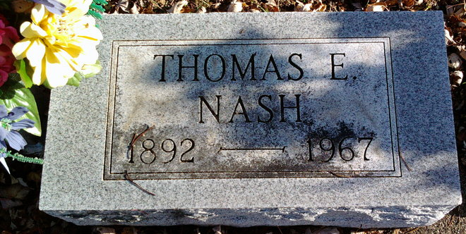
Photo by Thomas Liby

Indiana, U.S., Death Certificates, 1899-2017
Name Thomas Elihu Nash
Gender Male
Race White
Marital Status Married
Age 74y 8m 9d
Birth Date 20 Dec 1892
Birth Place Indiana
Death Date 29 Aug 1967
Death Place Bluffton, Wells, Indiana, USA
Death Registration Date 1967
Father John Nash
Mother Lydia Sowards
Spouse Goldine Gossard Nash, informant
Burial 8/31/1967 Fairview
**

Michigan, U.S., County Marriage Records, 1822-1940
Name Thomas E Nash
Gender Male
Age 21
Birth Date abt 1893
Marriage Date 11 Sep 1914
Marriage Place St Joseph, Michigan, USA
Father John A Nash
Mother Lydia Nash
Spouse Golda Gossard
Film Number 001295530

