Goldine Gladys (Gossard) Nash
November 13, 1896 – January 14, 1975

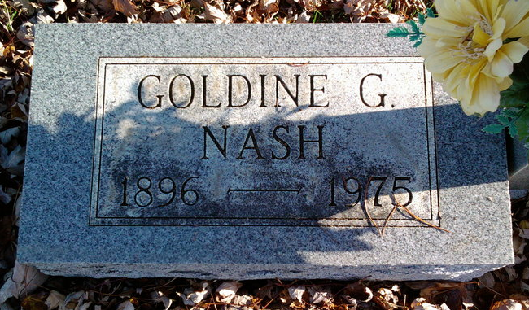
Photo by Thomas Liby

Mrs. Goldine G. Nash, 78, widow of Thomas Nash of Bluffton, died Tuesday afternoon in Meadowvale Care Center, Bluffton.
Surviving are three daughters, Mrs. Oral (Mary Ann) Fulton, Decatur; Mrs. Bonnie Reidenbach, Bluffton; Mrs. Don (Francetta) Hess, South Bend; and two sons, R. Stanley Nash, Fort Wayne, and Marshall D. Nash of Jeffersonville, Indiana. Her husband preceded her in death in August of 1967. Also surviving are 17 grandchildren and 19 great-grandchildren.
Services will be held at 2 p.m. Friday at the McBride Funeral Home. Calling after 7 p.m. Wednesday.

Decatur Daily Democrat, Adams County, Indiana
Wednesday, January 15, 1975
**

Indiana, U.S., Death Certificates, 1899-2017
Name Goldine G Nash
[Goldine G Gossard]
Gender Female
Race White
Marital Status Widowed
Age 78
Birth Date 13 Nov 1896
Birth Place Ohio
Death Date 14 Jan 1975
Death Place Bluffton, Wells, Indiana, USA
Father Francis M Gossard
Mother Nellie Lepley
Informant Bonnie Reidenbach, daughter
Burial Fairview Cemetery 1-17-1975

