Larry L. Myers
October 16, 1979 – September2, 2023

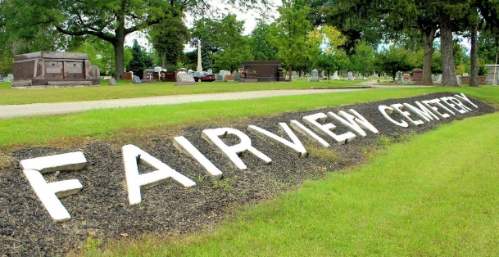
Photo by Tombstoner & Family

Larry L. Myers, 43, of Decatur, Indiana passed away Saturday, September 2, 2023 at his residence. He was born on October 16, 1979, in Decatur, Indiana to the late Harold Gene Myers and the late Peggy (Huss) Myers.
He was a 1999 graduate of Bellmont High School. He was also a member of the New Beginnings Faith Center in Decatur. He was one of the resident housekeepers at Golden Meadows…and he took great pride in his efforts and the staff greatly appreciated his work.
Survivors include his brother, William Myers of Bluffton, Indiana; two aunts, Donna Huss-Contino and Sharon Taylor both of Decatur, Indiana; three uncles, Rex (Betty) Huss of Hot Springs Village, Arkansas, Rick (Mary) Huss, and Dennis (Denise) Myers both of Decatur, Indiana.
Larry was preceded in death by uncles, Robert Huss, William Huss, and Rex Myers.
Private graveside services will be held at Fairview Cemetery in Bluffton.
Preferred memorials can be given to Stillwater Hospice or Mooseheart and mailed to the Zwick and Jahn Funeral Home in Decatur.

Zwick & Jahn Funeral Home, Adams County, Indiana
September 3, 2023

