Jacob Moseman/Mosiman
January 8, 1821 – January 28, 1904

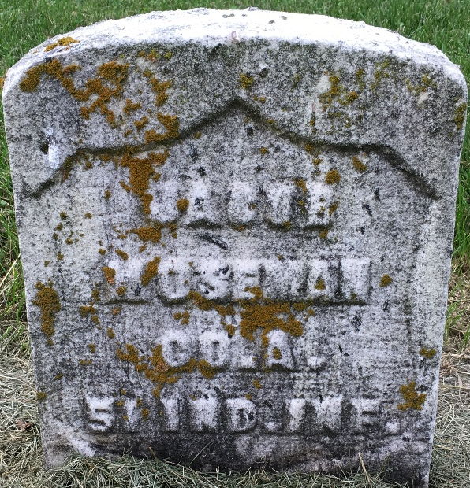
Photo by Barbara Baker Anderson

JACOB MOSIMAN DIED AT AGE OF EIGHTY-FOUR

Thursday P.M. at a few minutes before 6 o'clock, Jacob Mosiman breathed his last and after 82 years of usefulness on earth, he has gone to claim the rewards promised in heaven. Mr. Mosiman has been a sufferer for some time with asthma and this coupled with his weight of years, was the cause of his death.
Mr. Mosiman has been one of the pioneer residents of Wells county. In 1849 he came to this country with his wife, landing at New York city July 4. From New York he moved direct to Wells county and settled on a farm four and a half miles east of Bluffton. There he remained many years, seeing his children grow to manhood and womanhood and enjoying the fruits of his industry and sobriety.
Mr. Mosiman was born in Berne, Switzerland, January 8, 1821. Shortly after attaining his majority he was married to Miss Elizabeth Eigelberger. She accompanied him to this country to share with him the privations of a pioneer life. In August, 1868, his first wife died and later he was married to Miss Augusta Arnold. She lived until five years ago, when she, too, was called away. At that time he was living on his farm east of town. Later he moved to this city and for the past five years has resided with his son, Ferd Mosiman.
During the Civil war, Mr. Mosiman went out with a German regiment from Ohio and served during the four years. He was never a member of the G. A. R. here.
Mr. Mosiman leaves surviving him five children. They are Mrs. Mary Schoch, of Fort Wayne; Samuel Mosiman of South Bend; Fred Mosiman of Elwood; A. E. Mosiman of Anderson and Ferd Mosiman with whom he has made his home in this city.
During his life he became identified with the Methodist church and at the time of his death was a member of that church in this city.
The funeral was held Saturday at 2 p.m. at the house on West Wabash street and was in charge of his pastor, Rev. L. A. Beeks. From the house the remains were taken to Fairview cemetery where they were given interment.

Bluffton Banner, Wells County, Indiana
Wednesday, Feb. 3, 1904
**

U.S., Civil War Soldiers, 1861-1865
Name Jacob Mosiman
Side Union
Regiment State/Origin Indiana
Regiment 51st Regiment, Indiana Infantry; Company A
Rank In Private; Rank Out Private
Alternate Name Jacob/Moseman
Film Number M540 roll 54
**
Indiana, U.S., WPA Death Index, 1882-1920
Name Jacob Maseman
Date Jan 28, 1904
Location Bluffton
Age 83 Yr
Gender Male
Race White
Source location County Health Office, Bluffton
Source notes The source of this record is the book H-17 on page 1 within the series produced by the Indiana Works Progress Administration.
**
Jacob Mosiman from tree Arnold Branch from Holley, NY
Birth 5 Jan 1821 Sumiswald, Bern, Switzerland
Marriage 30 Aug 1869 Allen, Indiana, USA
Residence 1900 Bluffton, Wells, Indiana, USA
Death 28 Jan 1904 Bluffton, Wells, Indiana, USA
Father Ulrich Mosiman (1797-1861)
Mother Christiana Wymann (Born 1796)
Spouse Elizabeth Eigelbarger (1822-1868)
78630 People 7 Records 39 Sources

