Thomas Michael Morrissey
November 29, 1896 – August 3, 1967

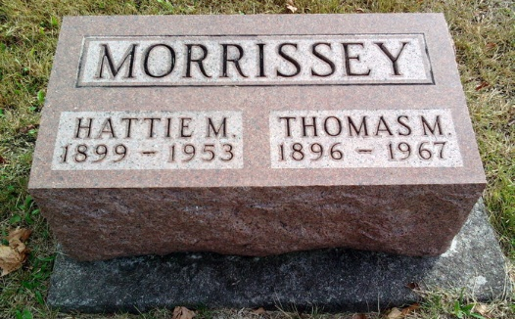
Photo by Thomas Liby

Thomas Morrissey found dead Sunday

Thomas M. Morrissey, 70, retired farmer, was found dead at 7 o’clock Sunday evening at his home on Uniondale route 1. His body was found by a son, Dale Morrissey, manager of the Haflich & Morrissey Shoe store in Decatur. Death, believed to have occurred Thursday, was attributed to cardiac failure. He was born in Ford county, Ill., Nov. 29, 1896, a son of James M. and Margaret Power-Morrissey. His wife, the former Hattie Pruitt, preceded him in death Feb. 28, 1953.
Mr. Morrissey was a member of St. Joseph’s Catholic church at Bluffton and its Holy name society. Well known in Decatur, he was a member of the Knights of Columbus and the Fourth Degree K. of C. here, and served as faithful scribe.
Surviving are two sons, Harold Morrissey of Winchester, and Dale Morrissey of Decatur; one sister, Mrs. Nellie Power of Peoria, Ill.; and seven grandchildren.
A requiem high mass will be conducted at St. Joseph’s Catholic church at Bluffton at 10 a.m. Wednesday, with Rev. Robert Traub officiating. Burial will be in Fairview cemetery at Bluffton. Friends may call at the Goodwin funeral home in Bluffton after 7 p.m. today. The rosary will be recited at 8 p.m. Tuesday.

Adams County (Indiana) Public Library
Obit Book D, Image 51
Dated August 6, 1967

