Hattie Marie (Pruitt) Morrissey
February 1, 1899 – February 28, 1953

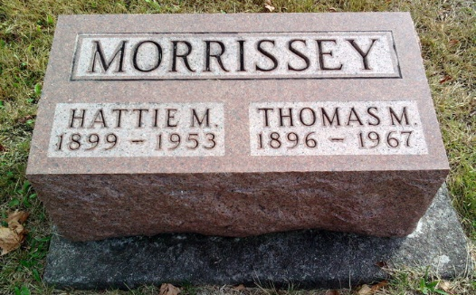
Photo by Thomas Liby

Indiana, U.S., Death Certificates, 1899-2017
Name Halcie Marie Morrissey
[Halcie Marie Pairett]
[Hattie Marie Morrissey]
Gender Female
Race White
Marital Status Married
Age 54
Birth Date 1 Feb 1899
Birth Place Missami, Webb City
Death Date 28 Feb 1953
Death Place Fort Wayne, Allen, Indiana, USA
Death Registration Date 1953
Father Thomas Pruitt
Mother Anna Gentis
Informant Mr. Thomas Morrissey
Burial 3/2/1953 Fairview
**
Illinois, U.S., County Marriage Records, 1800-1940
Name Hattie Marie Pruitt
Gender Female
Age 20
Birth Year abt 1900
Marriage Date 20 Jan 1920
Marriage Place Gibson City, Ford, Illinois, USA
Father Thos. Pruitt
Mother Anna Gentie
Spouse Thos Michael Morrissey

