Sarah Frances (White) Morgan
September 25, 1845 – May 7, 1923

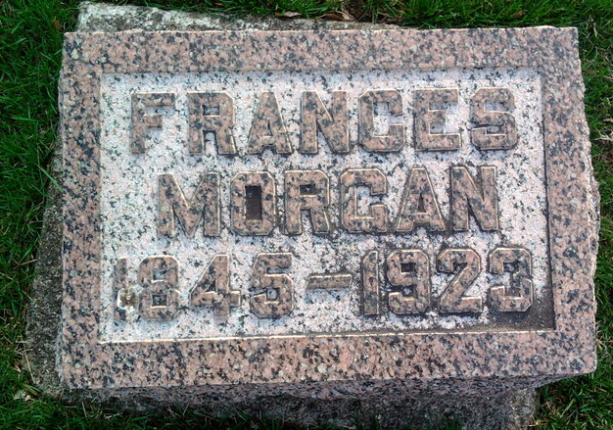
Photo by Thomas Liby

Indiana, U.S., Death Certificates, 1899-2017
Name Sarah Francis Morgan
[Sarah Francis White]
Gender Female
Race White
Marital Status Widower
Age 77y 7m 12d
Birth Date 25 Sep 1845
Birth Place Chillicot Co, Ohio
Death Date 7 May 1923
Death Place Bluffton, Wells, Indiana, USA
Death Registration Date 1923
Father Jackson E. White
Mother Anna Groves
Spouse David Morgan
Informant J E. Morgan, Coldwater, Mich.
Burial Fairview 5/9/1923

