Eli Richard Morgan
August 12, 2010 – August 12, 2010

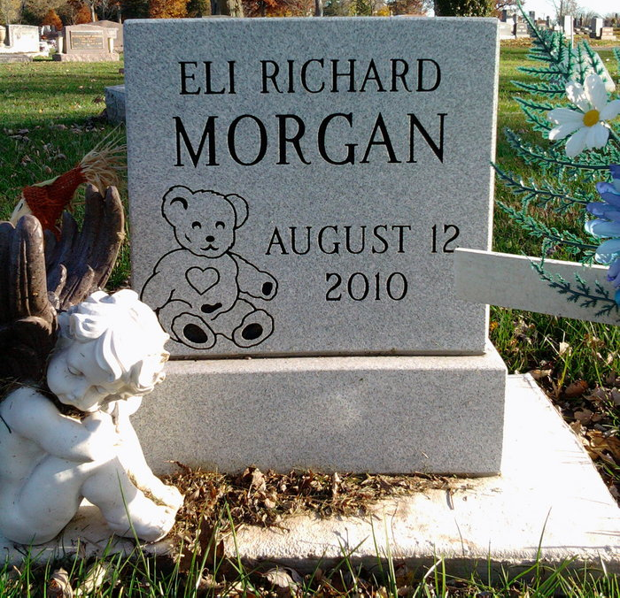
Photo by Thomas Liby

Eli R. Morgan, infant, died Thursday, Aug. 12, 2010, at Lutheran Hospital in Fort Wayne. Eli was born Thursday to Nathen R. Morgan and Crystal N. Sage, both of Bluffton.
Other surviving relatives include one sister, Hayden Morgan of Montpelier; one brother, Connor Morgan of Montpelier; great-grandparents Paul and Nina Price of Columbia City; grandparents, Cathy Ferguson of Bluffton, Charles Sage of Bluffton, Janice Morgan of South Whitley, and Paul (Donna) Morgan of Liberty Center; uncles, Ian Morgan of Columbia City and Chad Sage of New Haven.
Graveside funeral services and burial will be at 3 p.m., Sunday, Aug. 15, at Fairview Cemetery in Bluffton.

Thoma/Rich, Chaney and Lemler Funeral Home, Wells County, Indiana

