David F. Morgan
December 30, 1844 – April 18, 1903

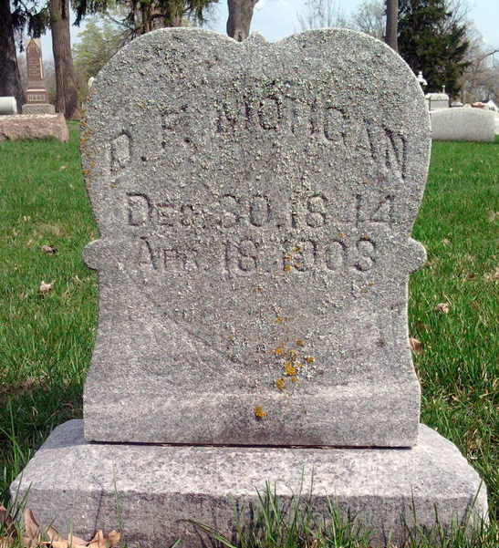
Photo by Thomas Liby

SICK ONLY TEN DAYS
David Morgan Died This Morning at His Home on Cherry Street
Funeral Monday.

David Morgan passed away at his home on West Cherry Street at eight o’clock Saturday after a sickness of only ten days. Two weeks ago Wednesday night he commenced work as a night policeman on the West Side. He worked just a week in that position when he was taken ill with congestion of the lungs due it is thought to exposure in the night air. His sickness developed into pneumonia and its complications and caused his death.
The funeral was held from the residence at two o’clock Monday afternoon. The services were in charge of Rev. L. A. Beeks of the Methodist Church and interment occurred in Fairview cemetery. The members of the city fire department and of the Federation of Labor to both of which Mr. Morgan belonged will attend the funeral in a body. Mr. Morgan had been a member of the fire department for over fifteen years.
The deceased was a son of Mr. And Mrs. John Morgan and was born in Good Hope, Fayette County, Ohio, January 1, 1844. When a very young man he came to Indiana and was married on February 25, 1860 to Miss Frances White, a daughter of Jackson White and wife. They went to Illinois where they lived two years and then returned to Bluffton where they have resided continuously since.
Seven children were born to Mr. And Mrs. Morgan, all of whom are living. They are Ferd and Fred, the twins, Olrlano, Edwin, Nellie, Muff and Mrs. Aurora Wolf of Muncie. A brother and sister survive Mr. Morgan. They are Noah Morgan and Mrs. Mary Garrett of Good Hope, Ohio.

BLUFFTON EVENING NEWS, Wells County, Indiana
April 20, 1903, Page 3 Column 3
**

The funeral of D. F. Morgan was very largely attended this afternoon. In the line of march from the church to Fairview there were the city gre department, city council, street cleaners and in fact every one of the city officials. They were followed by the Federation of Labor sixty strong and by relatives and friends. The funeral service was preached by Rev. Beeks, of the M. M. Church.

BLUFFTON CHRONICLE, Wells County, Indiana
April 22, 1903, Page 6 Column 4

