Marion L. Mooneyhan
November 9, 1934 – August 20, 2018

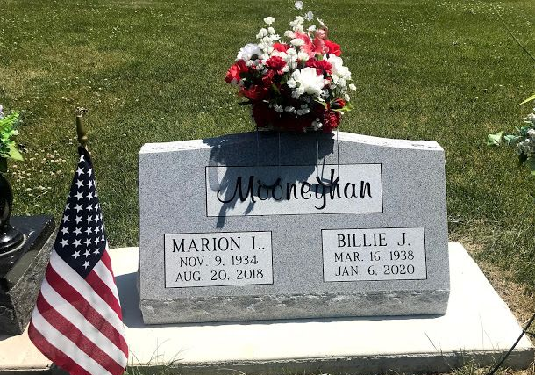
Photo by SMMR

Marion Mooneyhan age 83 of Pikeville, formerly of Versailles, OH passed away Monday August 20, 2018 at the Parkview Nursing and Rehab Center. He was born on November 9, 1934 to the late Archie Mooneyhan and Dulcie Rose Mooneyhan.
Other than his parents he was preceded in death by his one son; Ron Mooneyhan and two sisters; Geneva Hampton and Ruby Jane Campbell.
He is survived by his wife; Billie Jo Harmon Mooneyhan of Pikeville, one daughter; Debbie Thomas of Pikeville, three brothers; Virgil Mooneyhan of Greely, CO, Daniel Mooneyhan of El Paso, TX, James Mooneyhan of Bluffton, IN, three grandchildren; Jennifer, Matt, Mark and one great grandchild; Kaden.
A graveside service to celebrate Marion’s life will be held at 2 P.M. on Saturday, September 1, 2018, at Fairview Cemetery in Bluffton with Jeff Lemler officiating.
Thoma/Rich, Lemler Funeral Home, Wells County, Indiana
September 2, 2018

